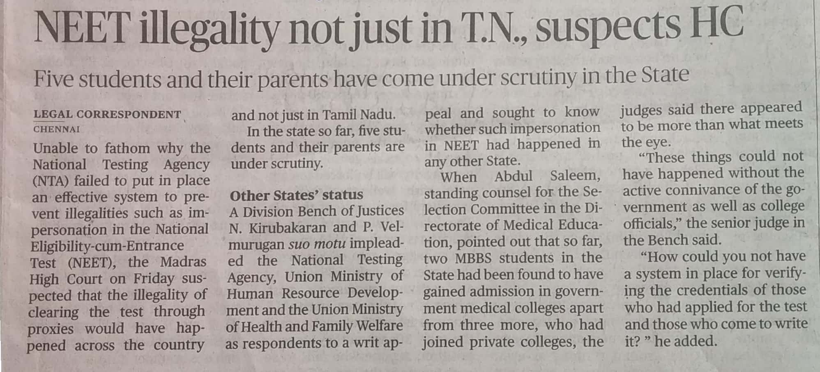

The Hindu 05 Oct. 2019