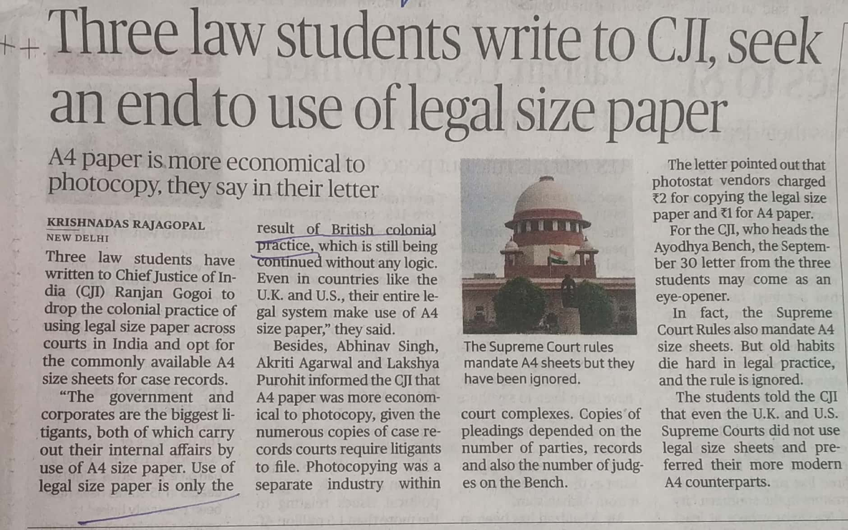

The Hindu 06 Oct. 2019