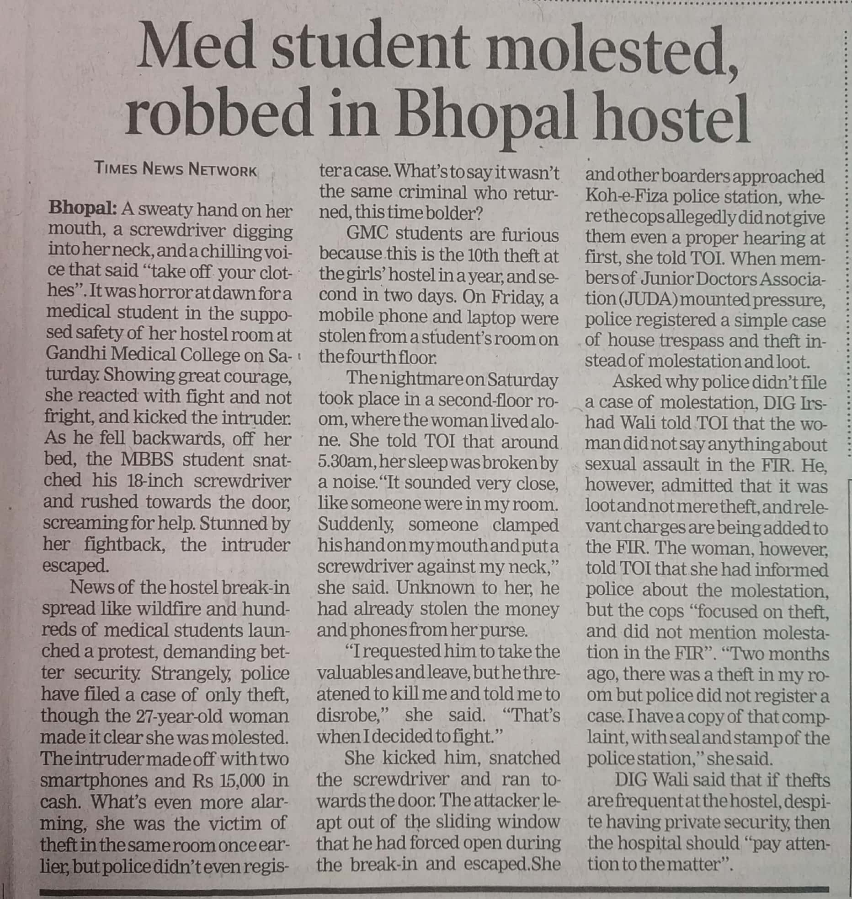

Times of India 06 Oct. 2019