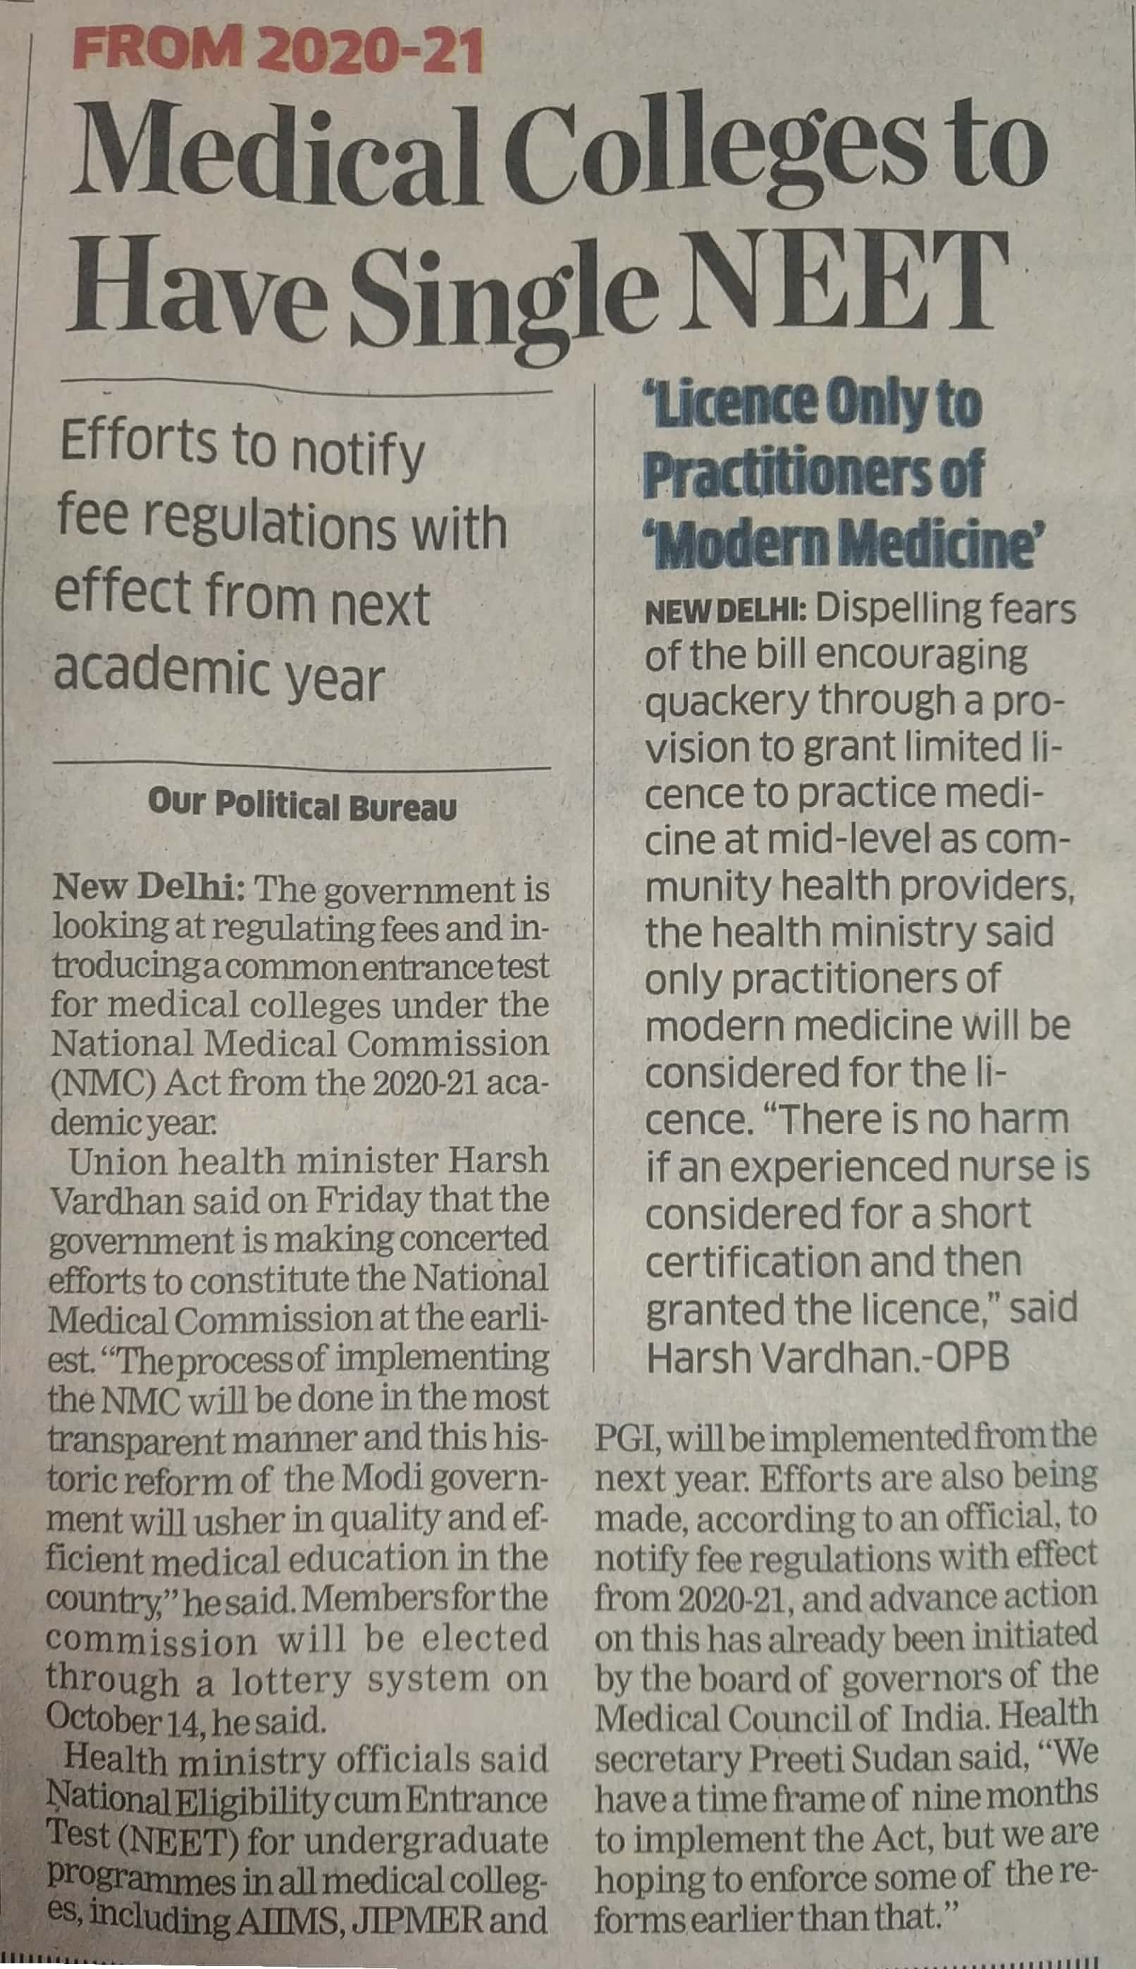

Economics Times 05 Oct. 2019