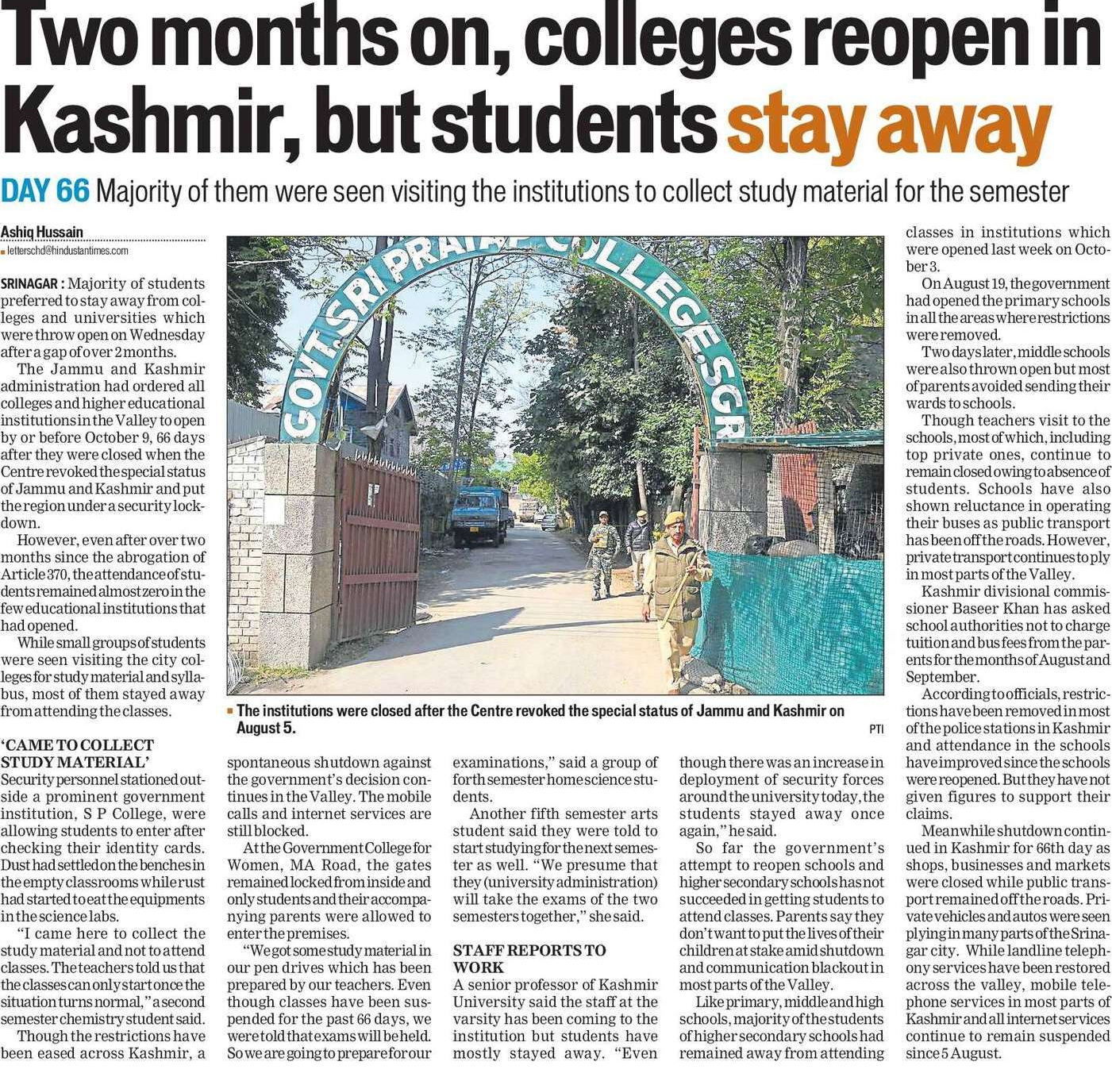

Hindustan Times 10 Oct. 2019