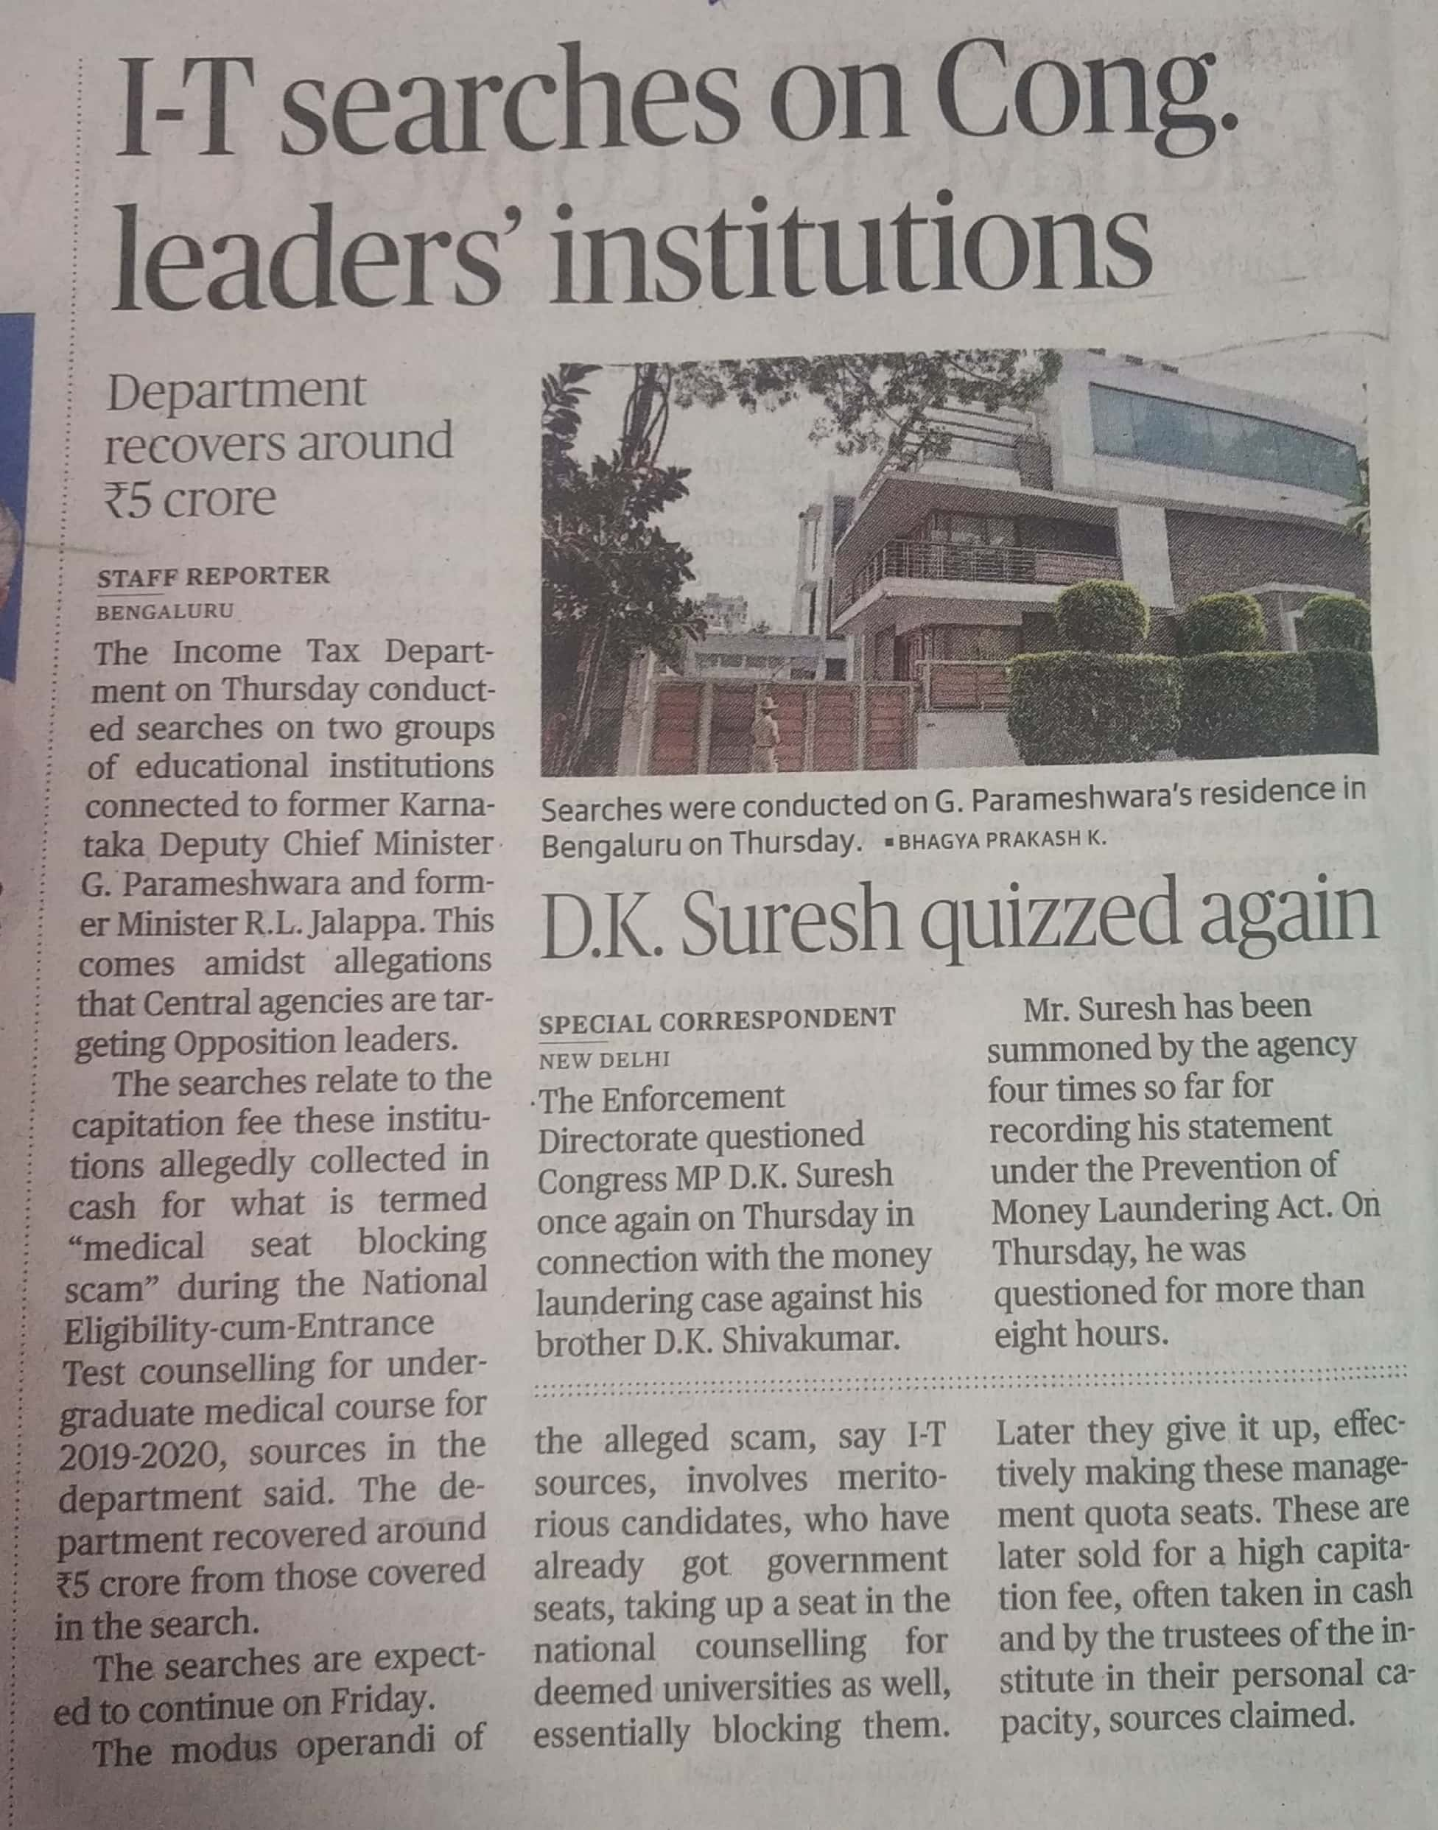

The Hindu 11 Oct. 2019