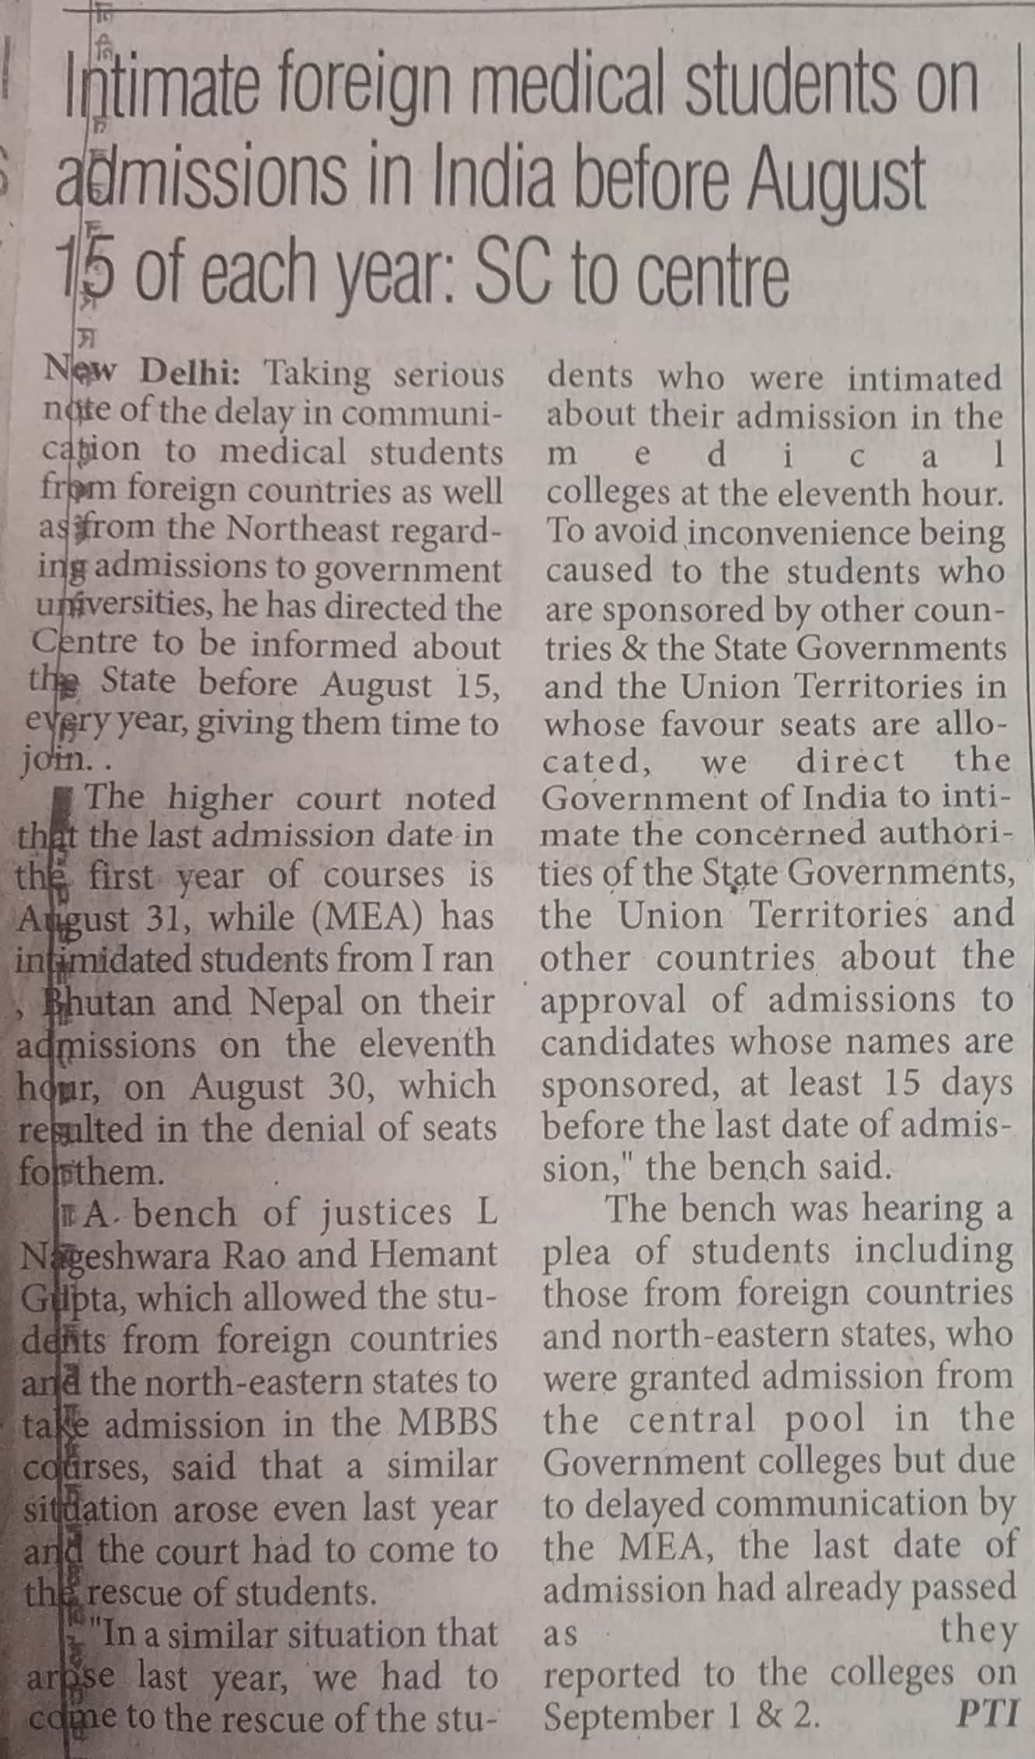
The Pioneer 11 Oct. 2019

