

Financial Express 16 Oct. 2019 Continued on Next pg

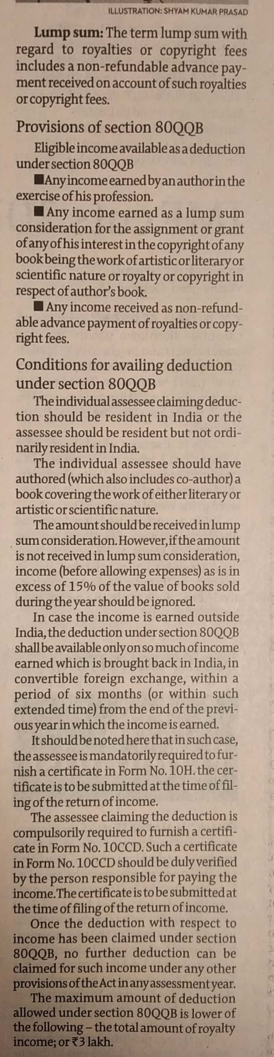

Financial Express 16 Oct. 2019