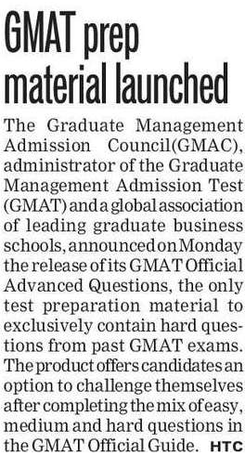

Hindustan Times 16 Oct. 2019