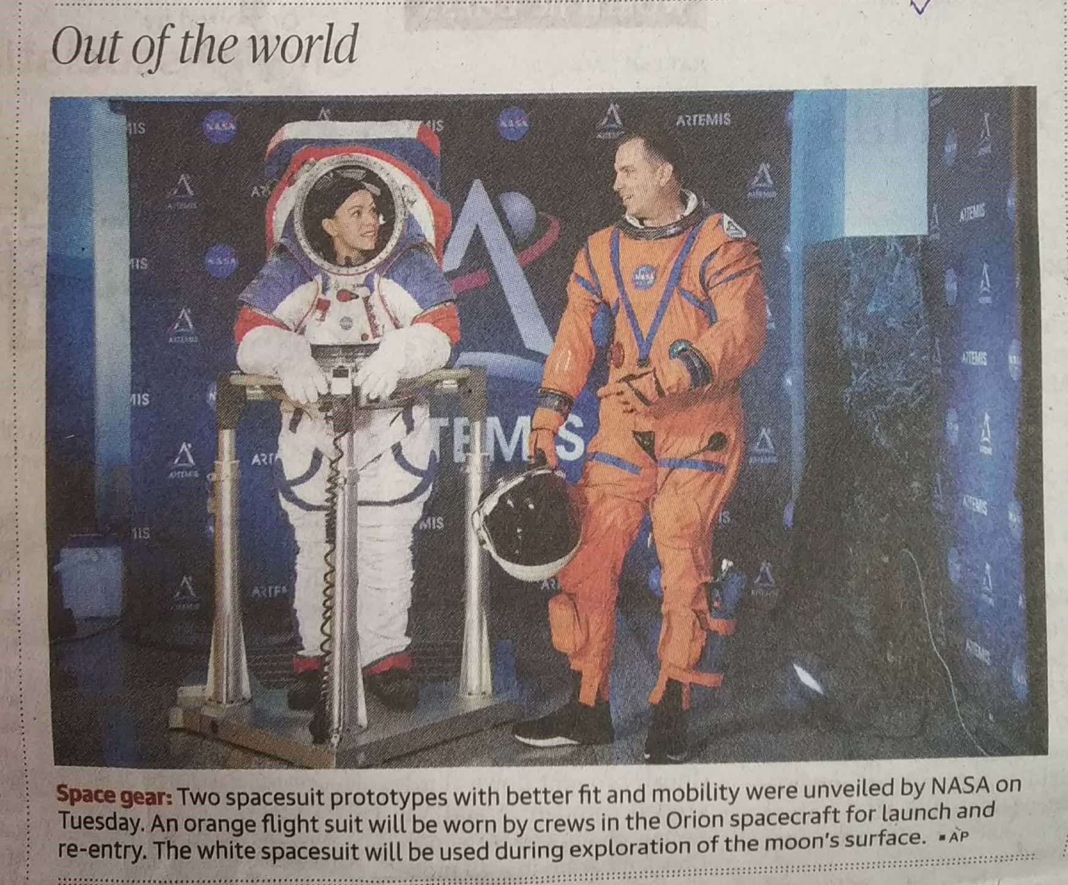

The Hindu 17 Oct. 2019