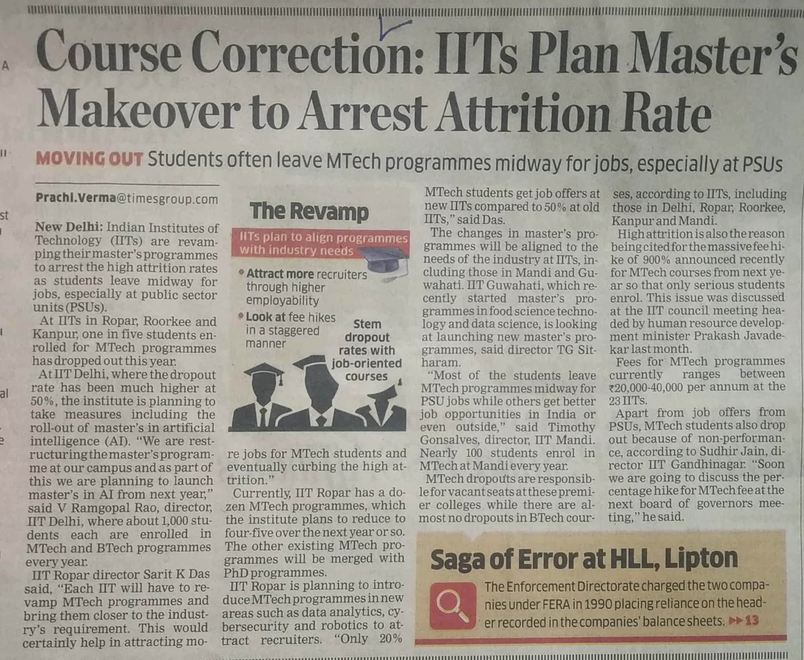

Economics Times 09 Oct. 2019