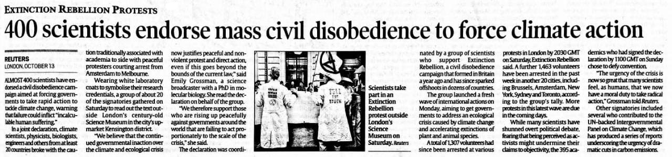

Indian Express 14 Oct. 2019