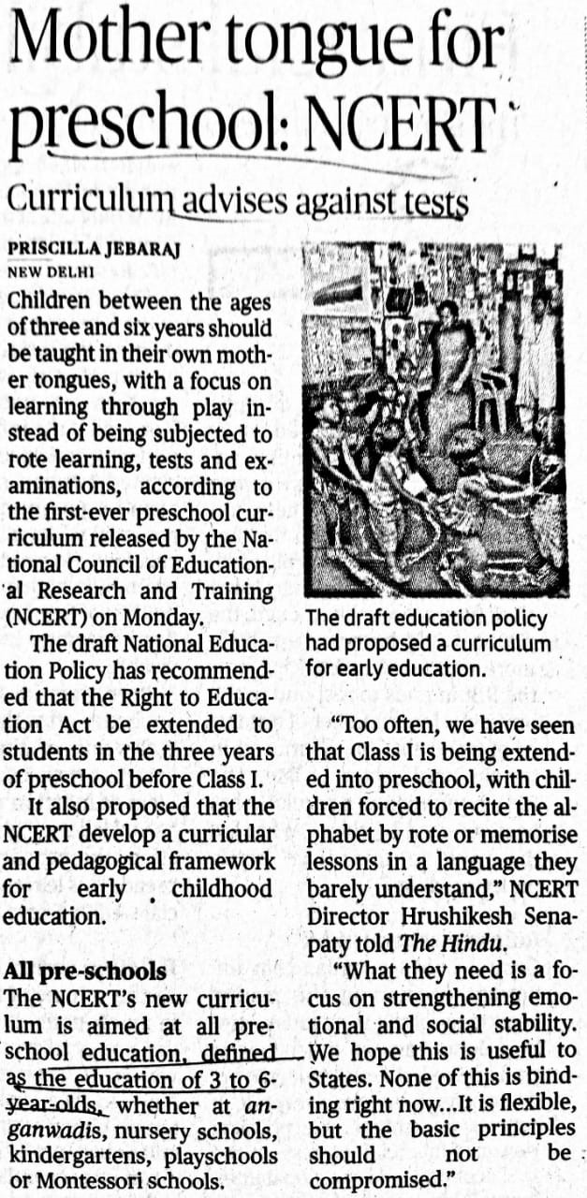

The Hindu 15 Oct. 2019