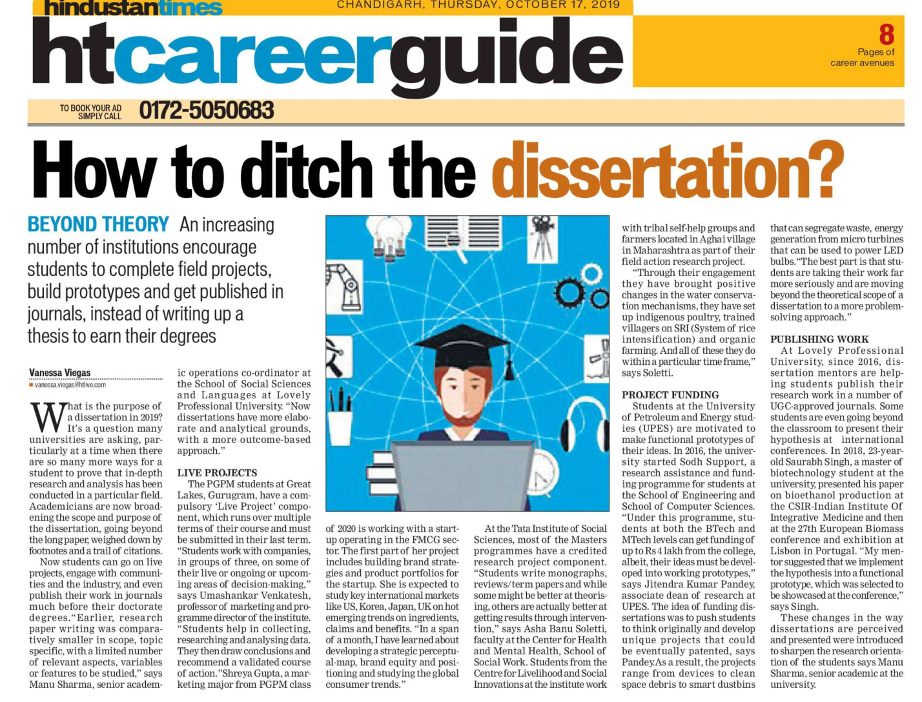
Hindustan Times 17 Oct. 2019

