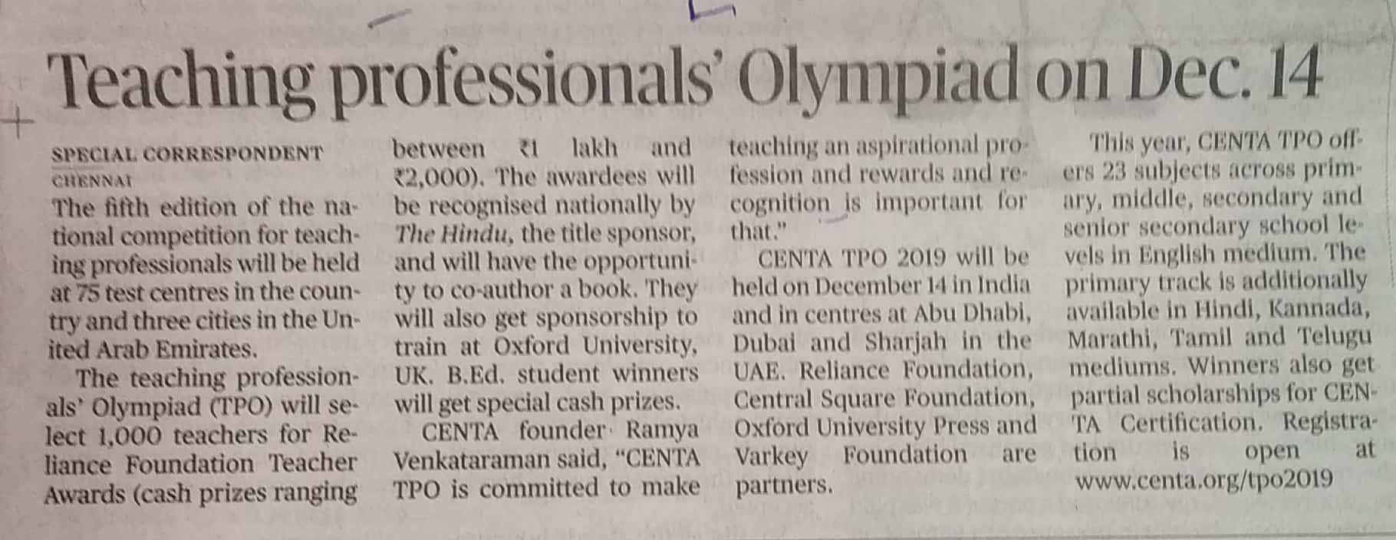

The Hindu 18 Oct. 2019