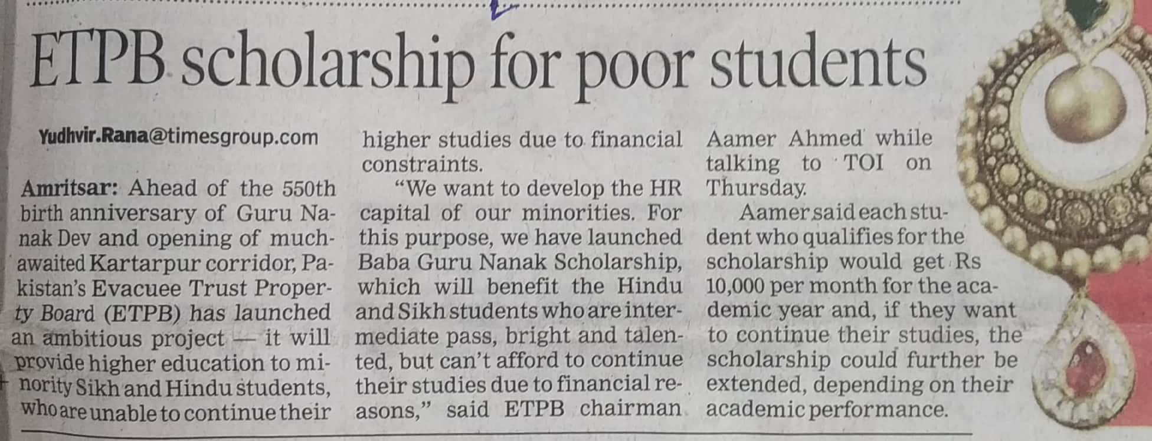

Times of India 18 Oct. 2019