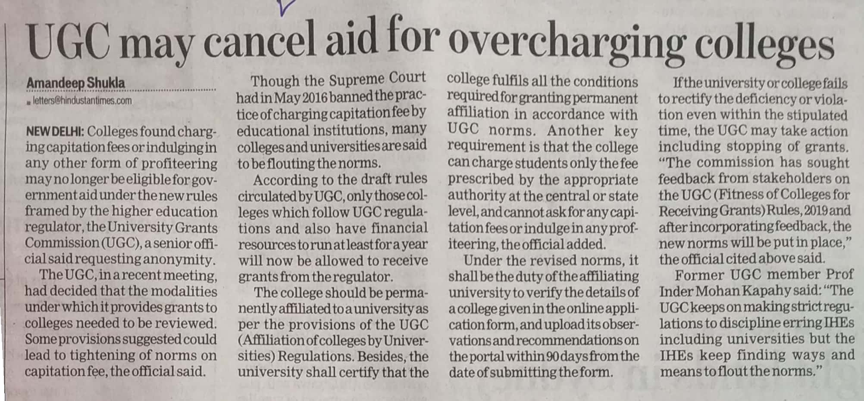

Hindustan Times 21 Oct. 2019