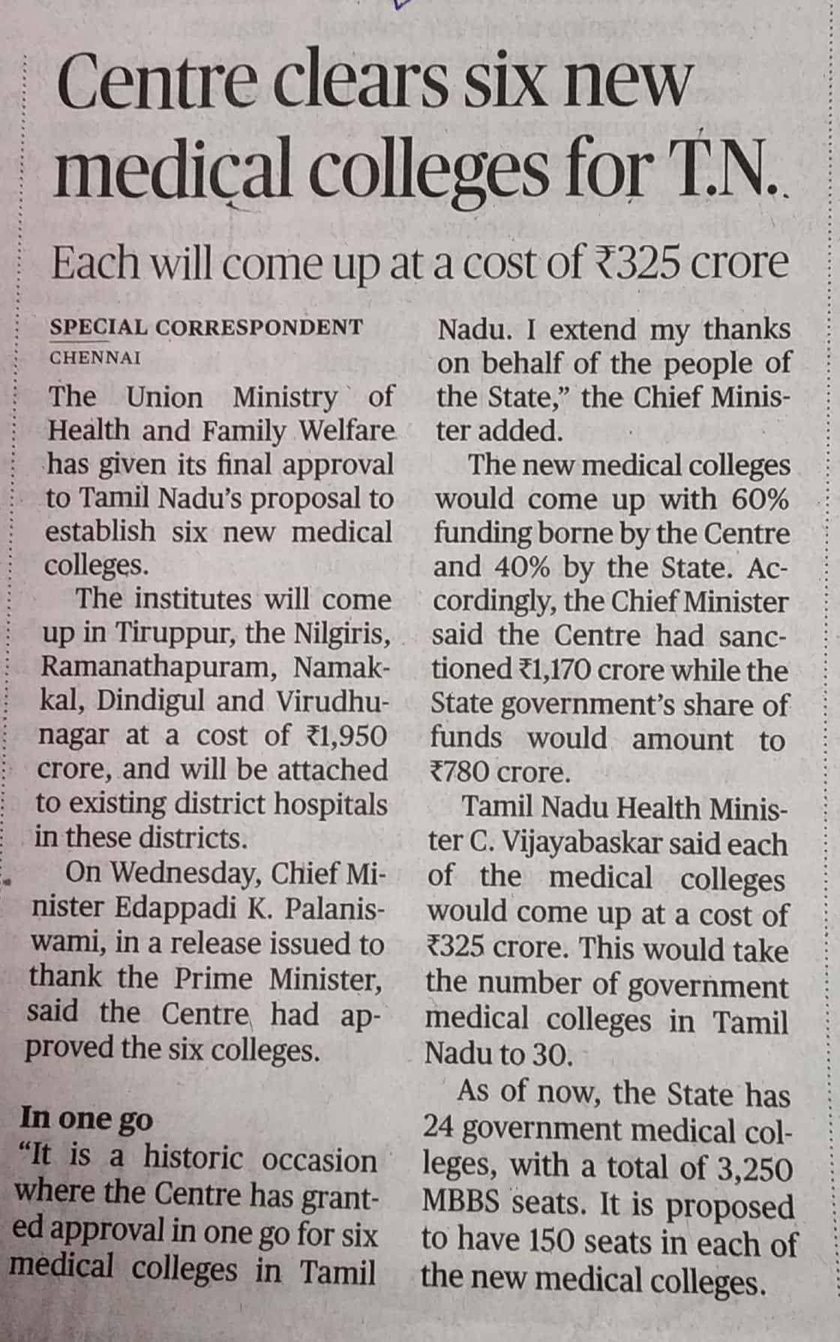

The Hindu 24 Oct. 2019