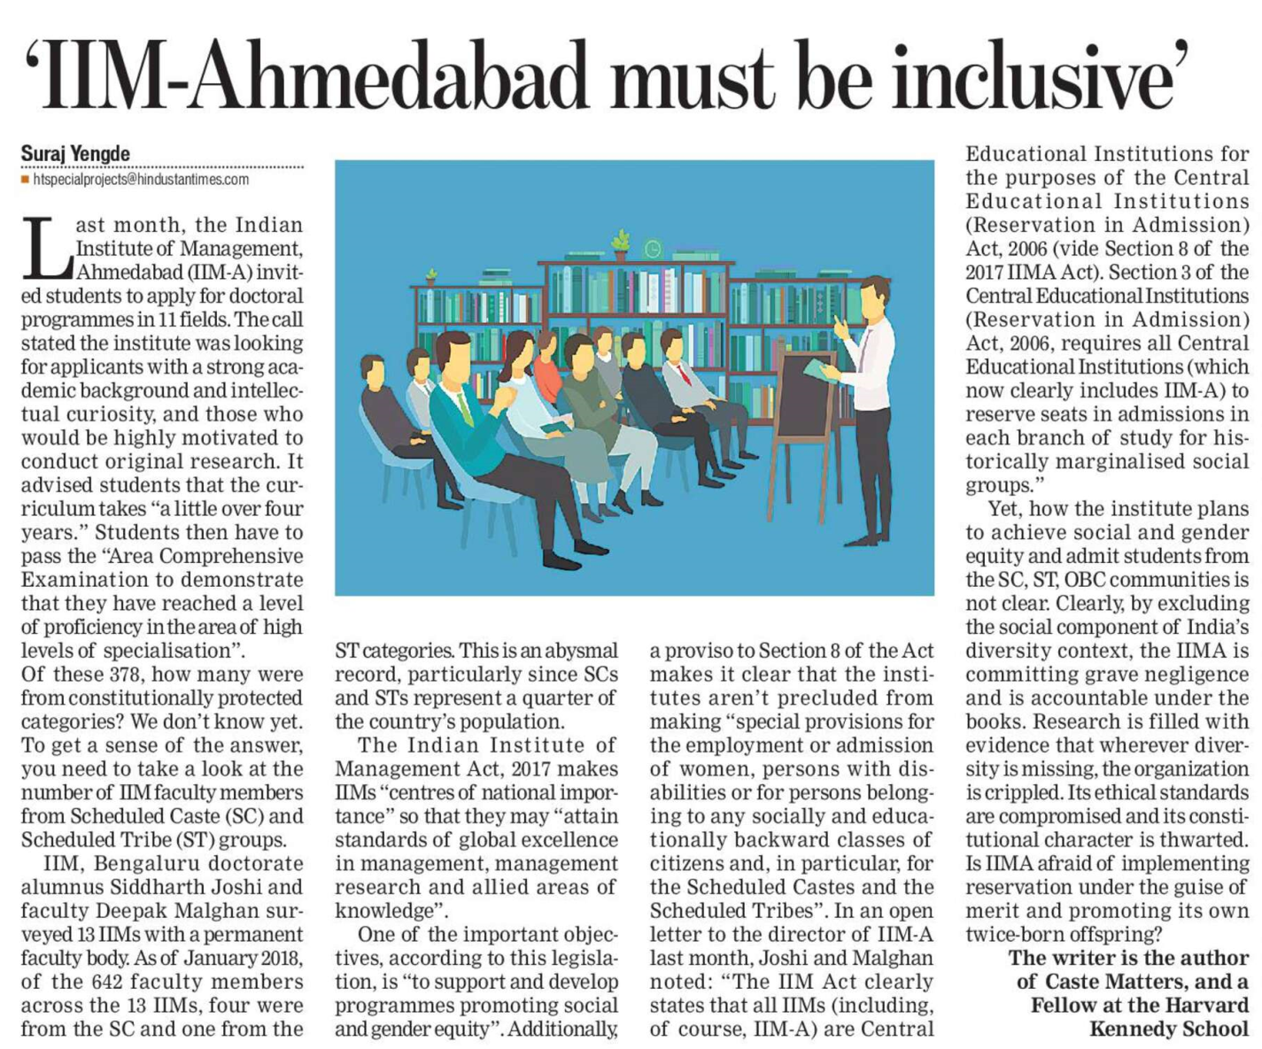

The Hindustan Times 24 Oct. 2019