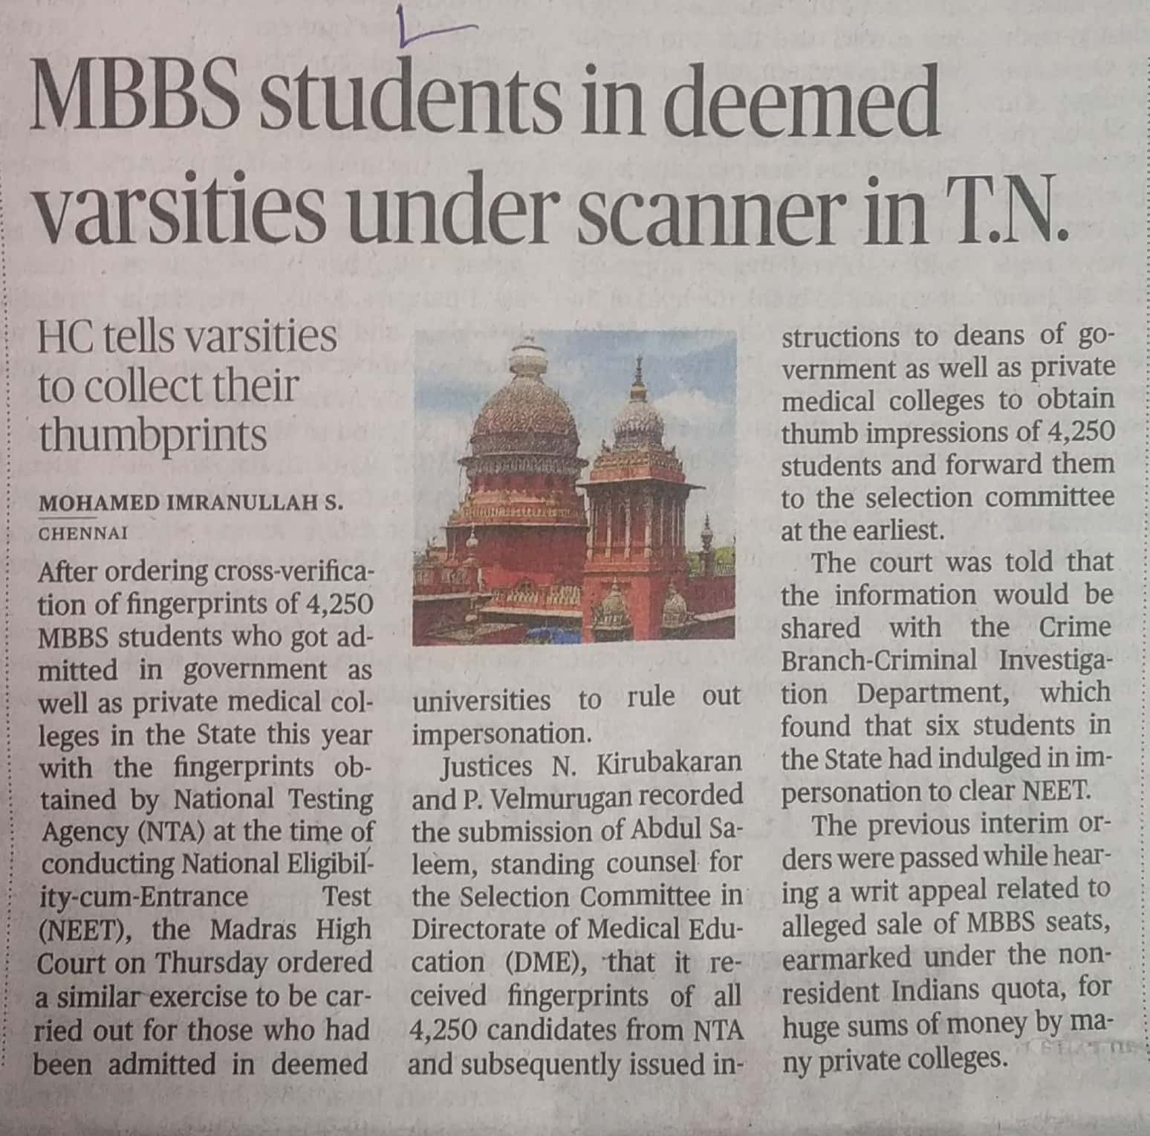

The Hindu 25 Oct. 2019