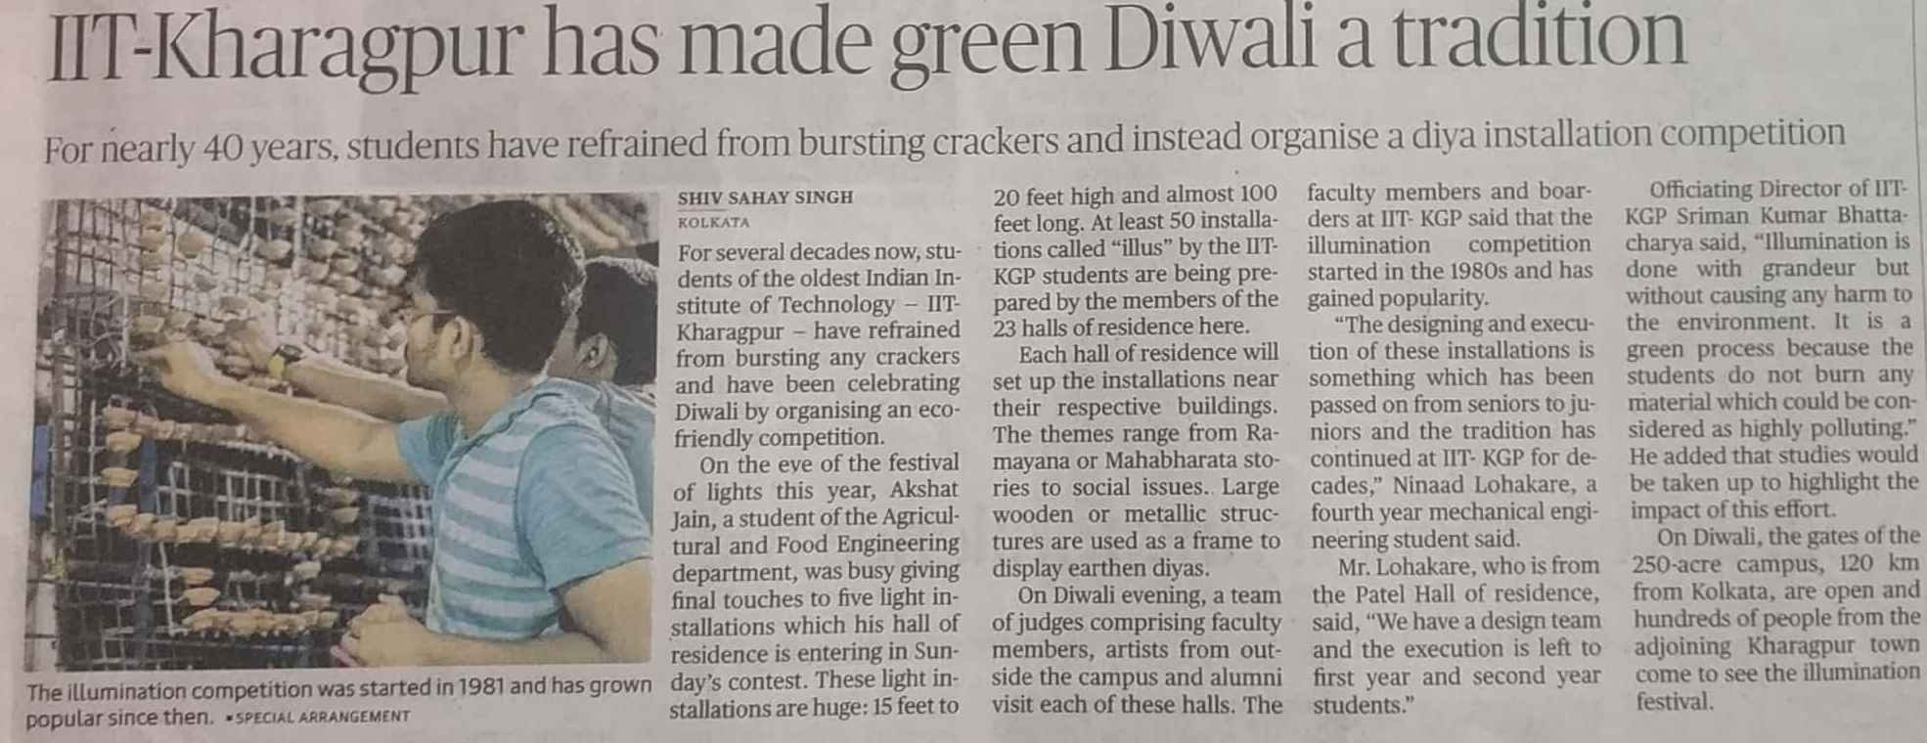

The Hindu 27 Oct. 2019