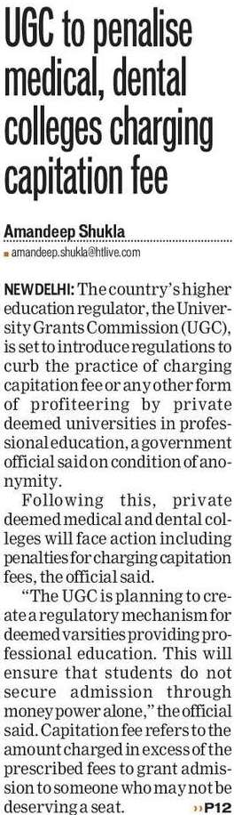

The Hindustan Times 27 Oct. 2019

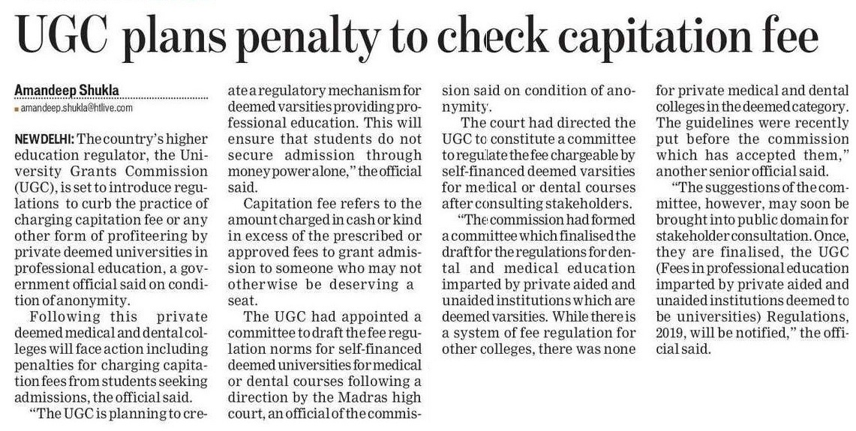

The Hindustan Times 27 Oct. 2019