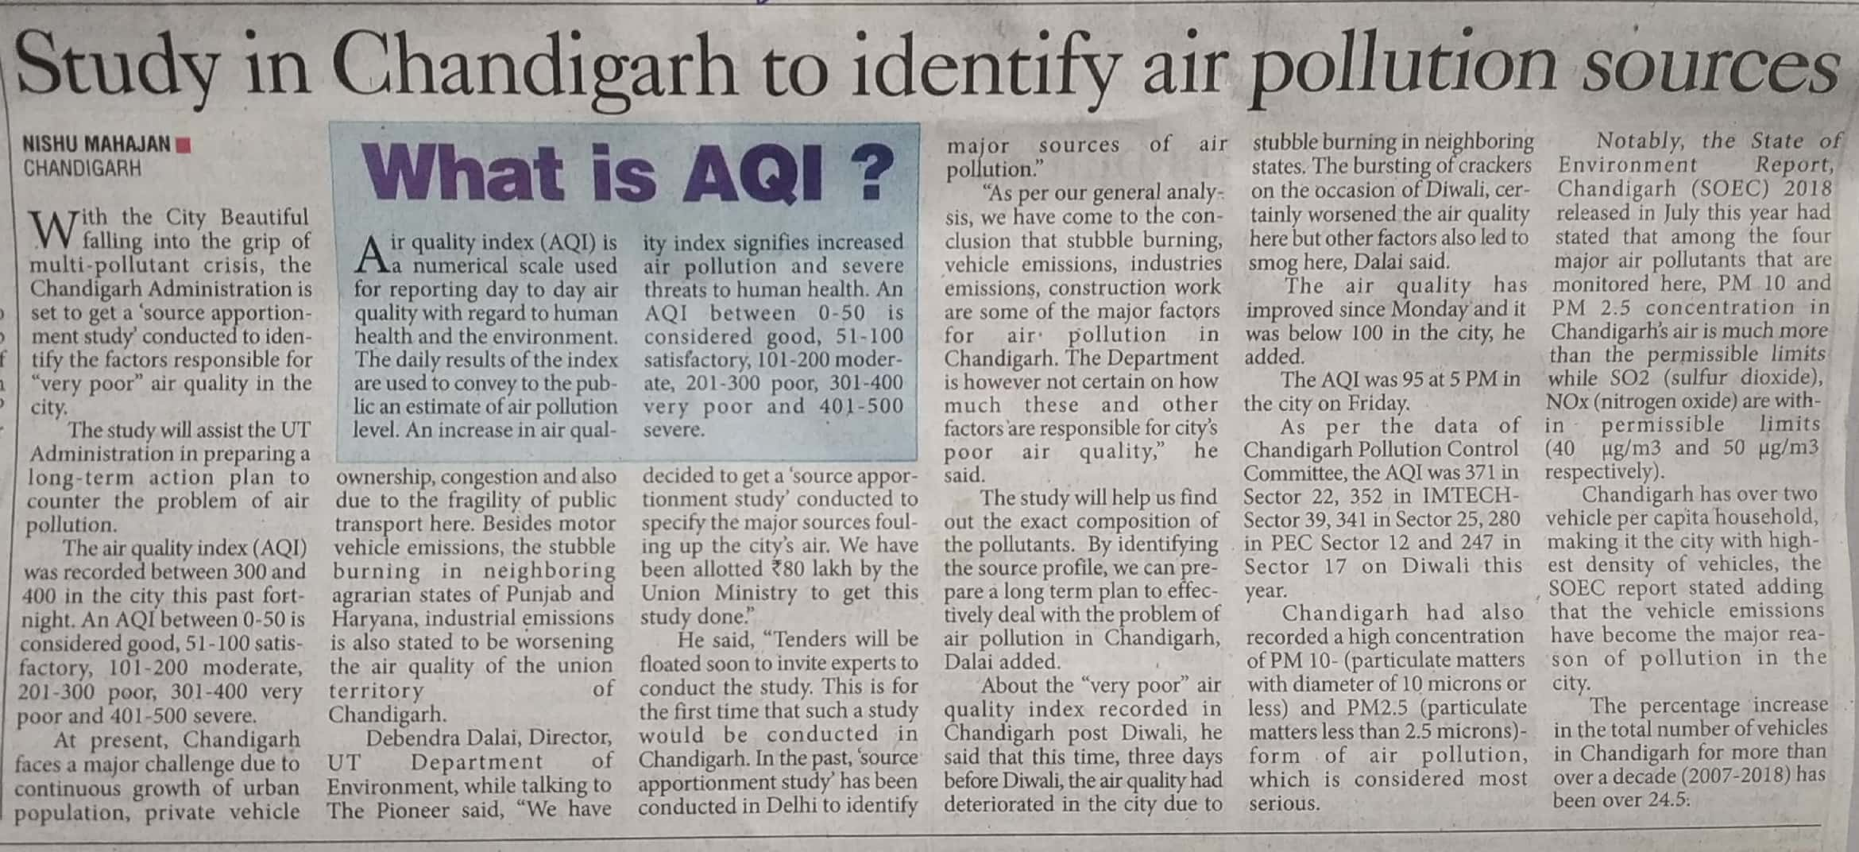

The Pioneer 10 Nov. 2019