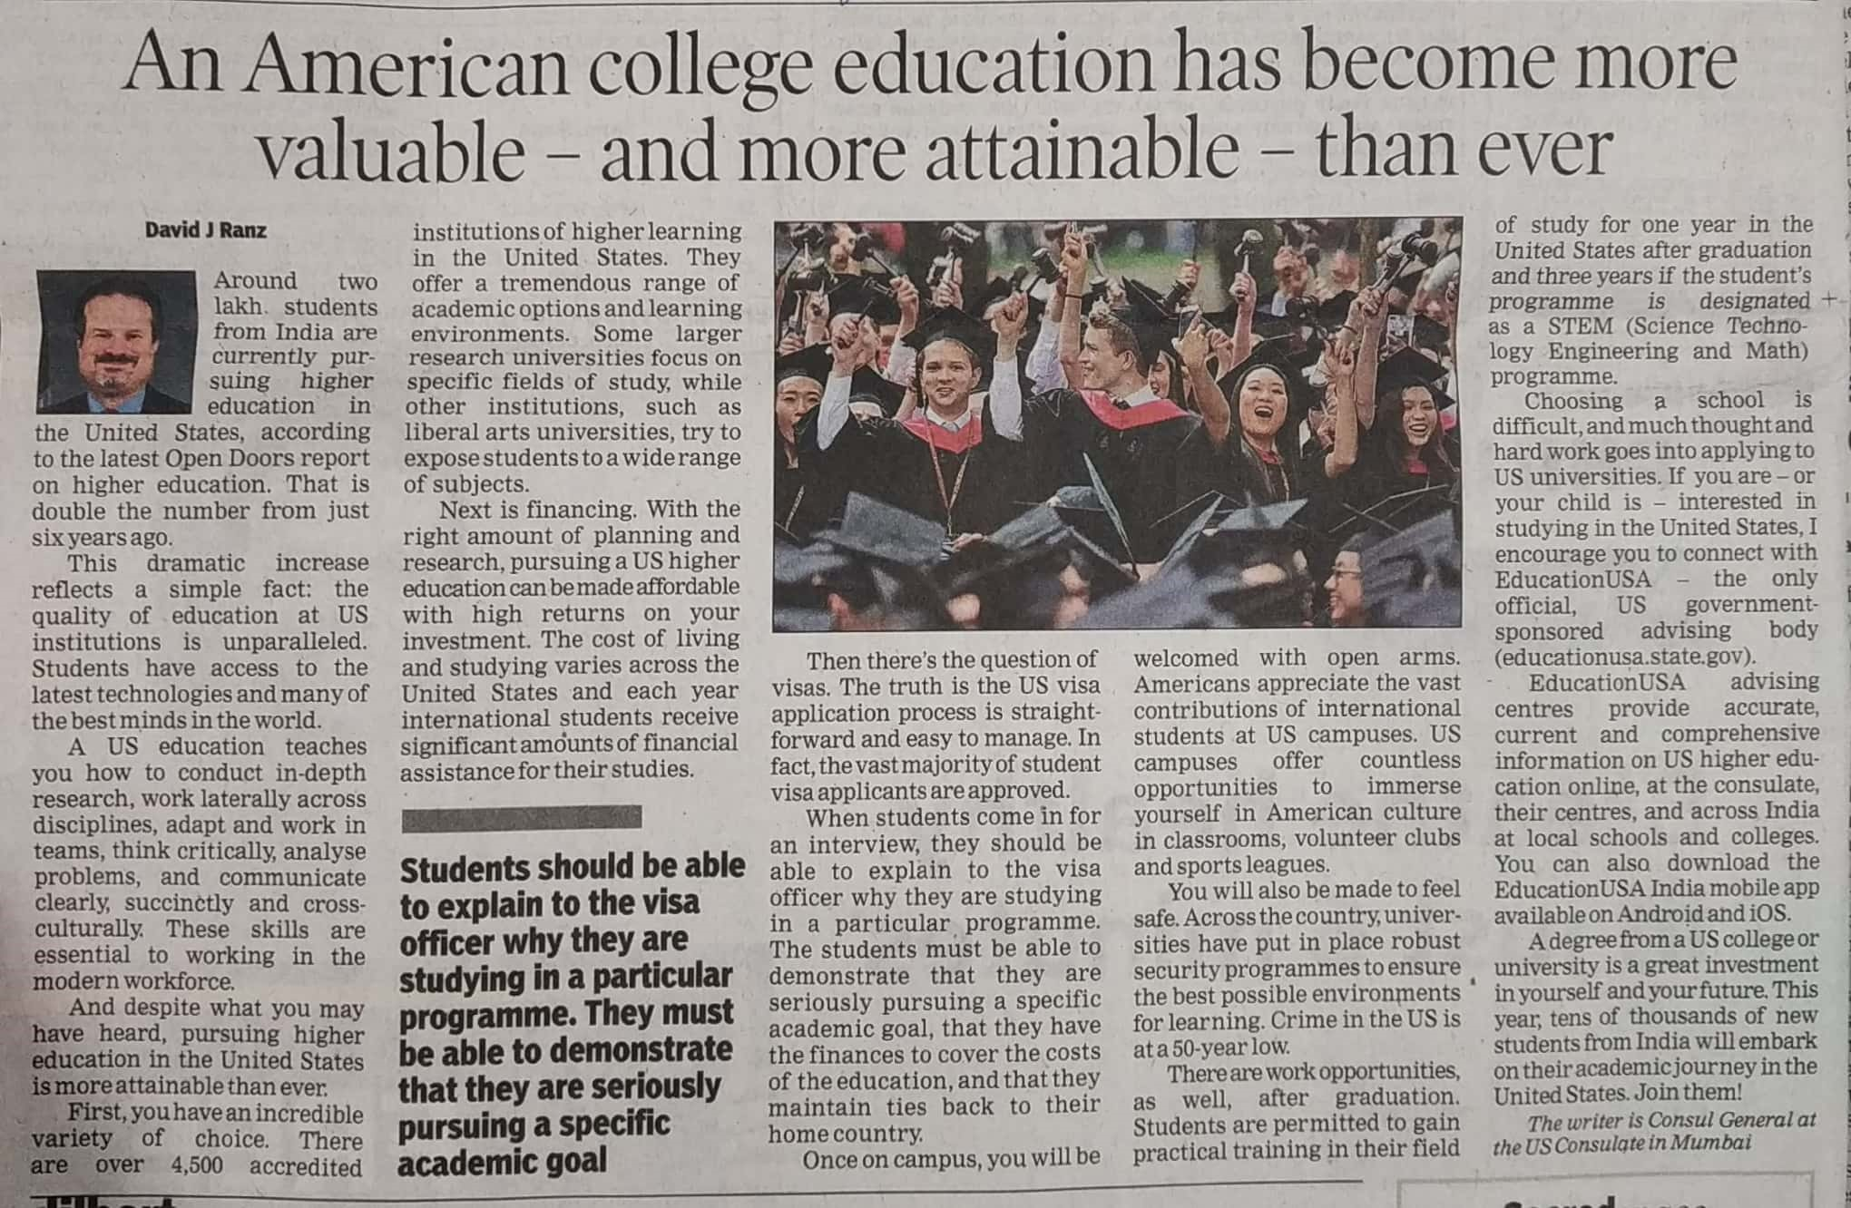

Times of India 19 Nov. 2019