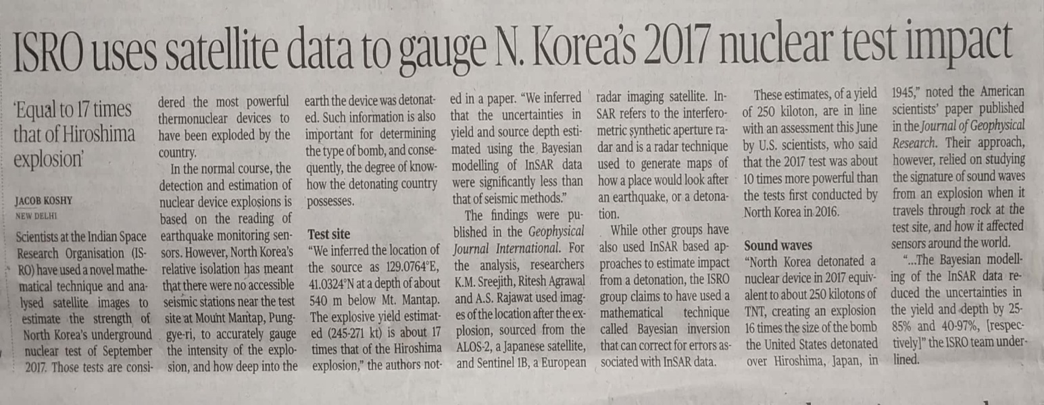

The Hindu 21 Nov. 2019