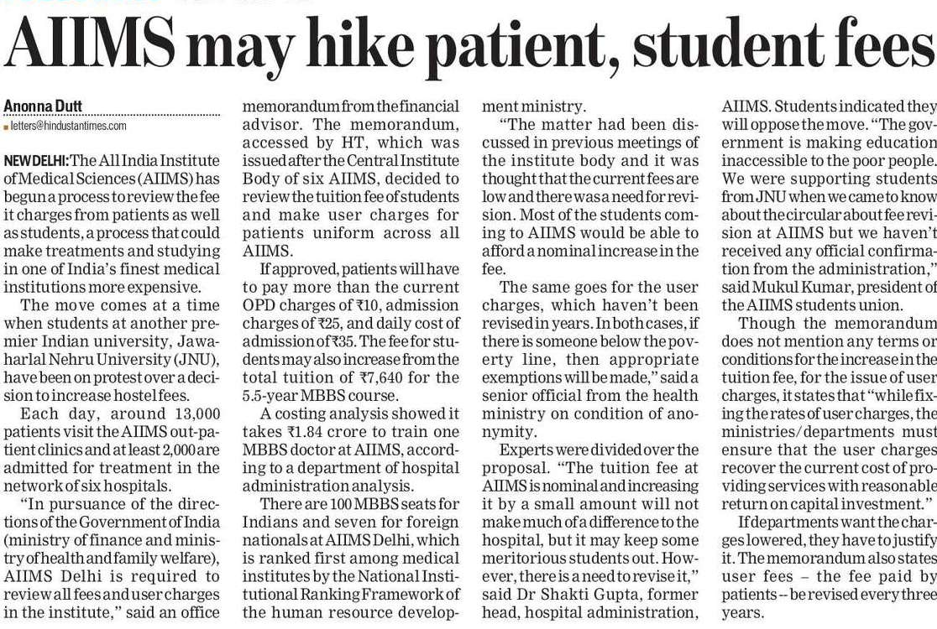

Hindustan Times 23 Nov. 2019