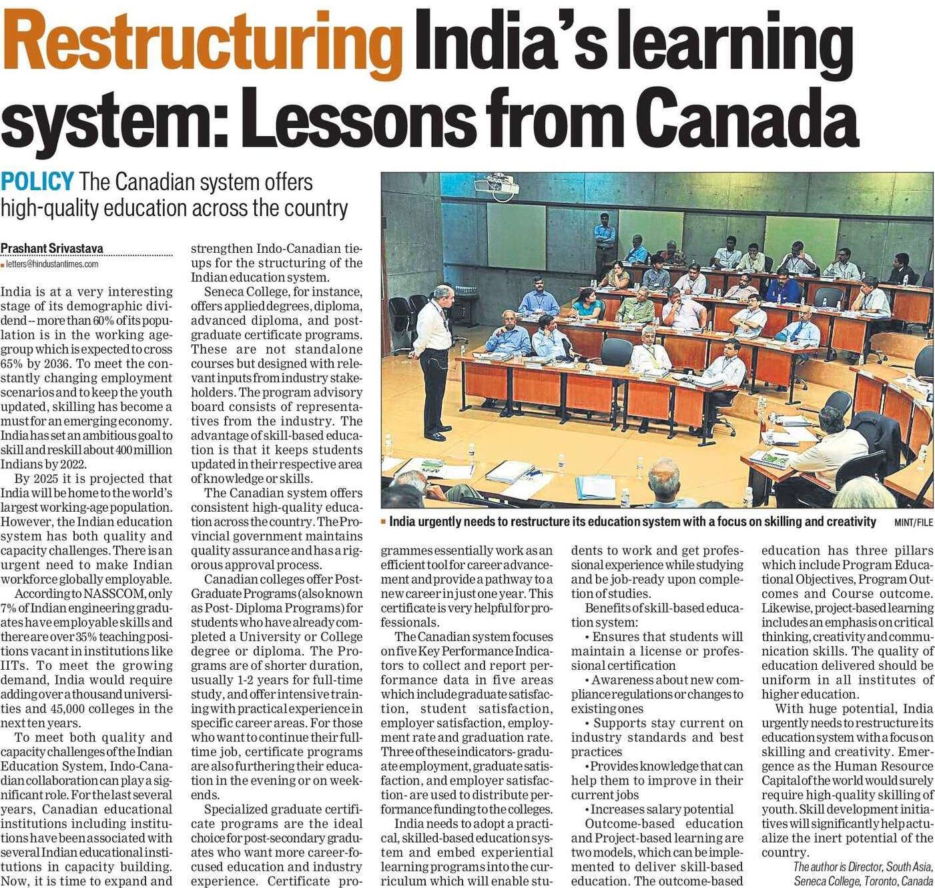

Hindustan Times 27 Nov. 2019