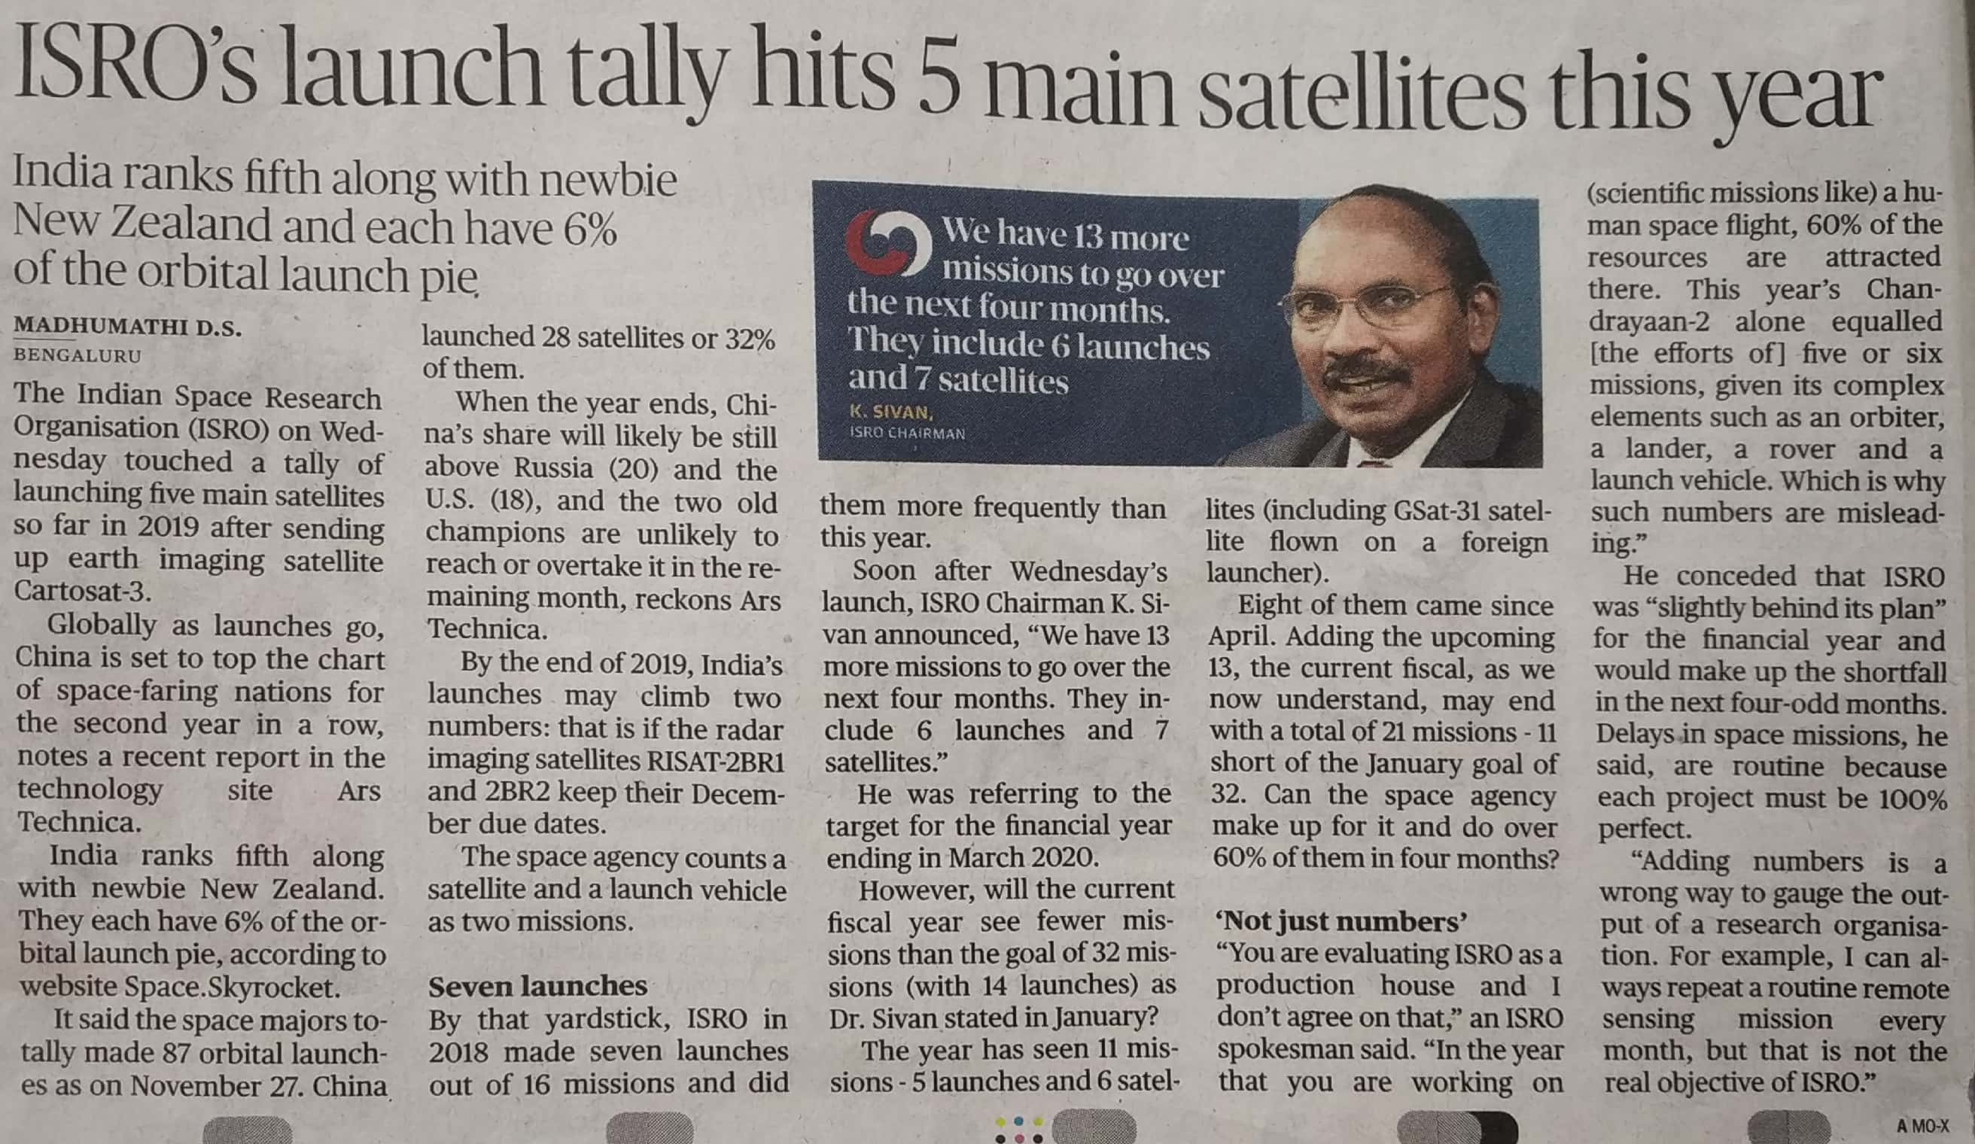

The Hindu 28 Nov. 2019