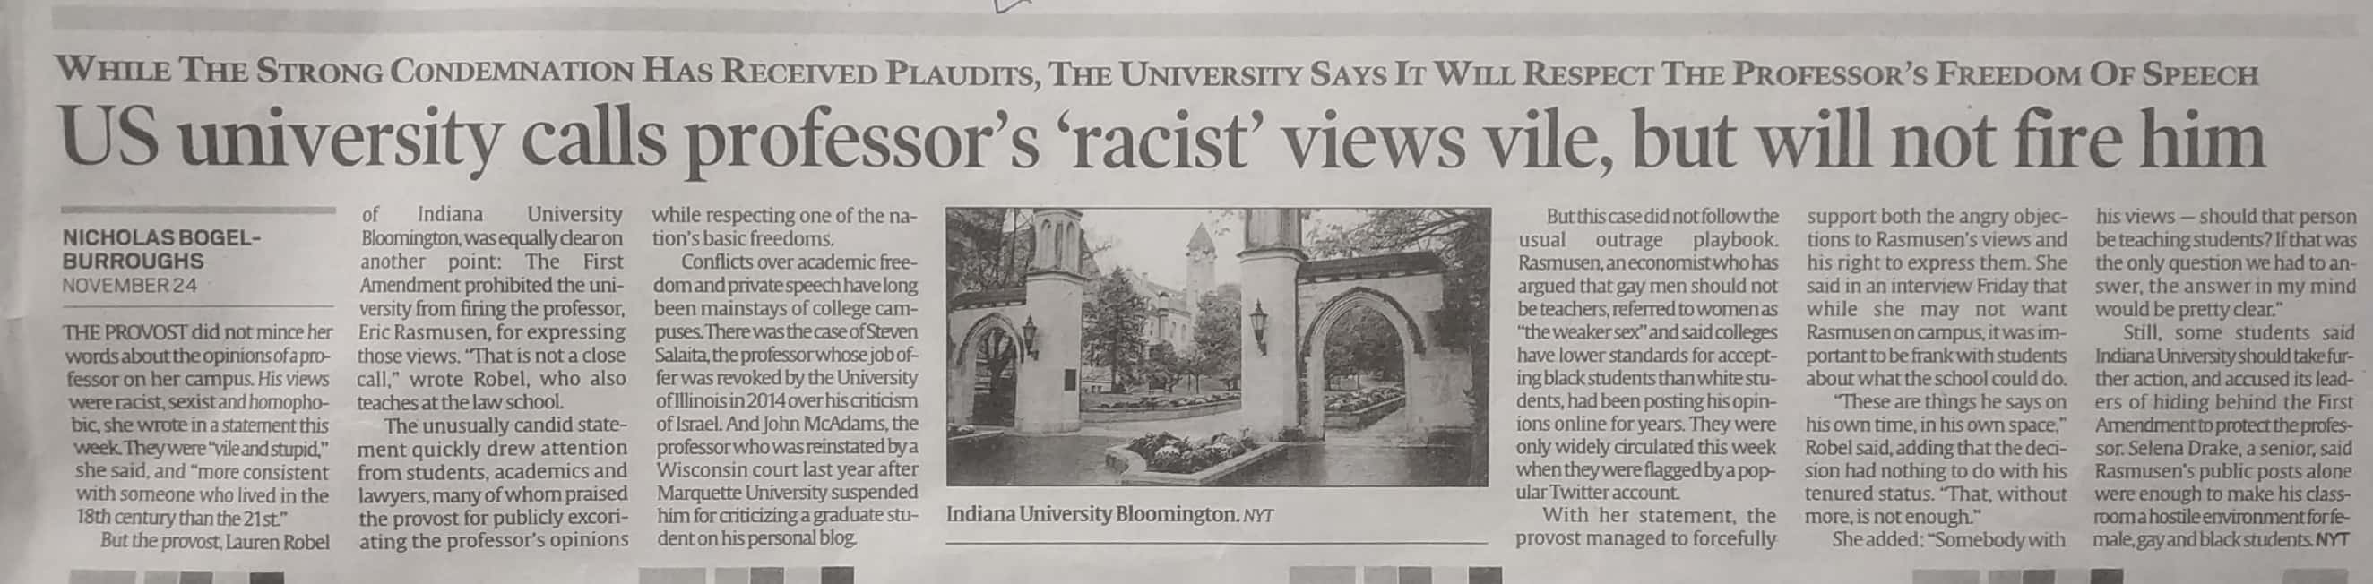

Indian Express 25 Nov. 2019