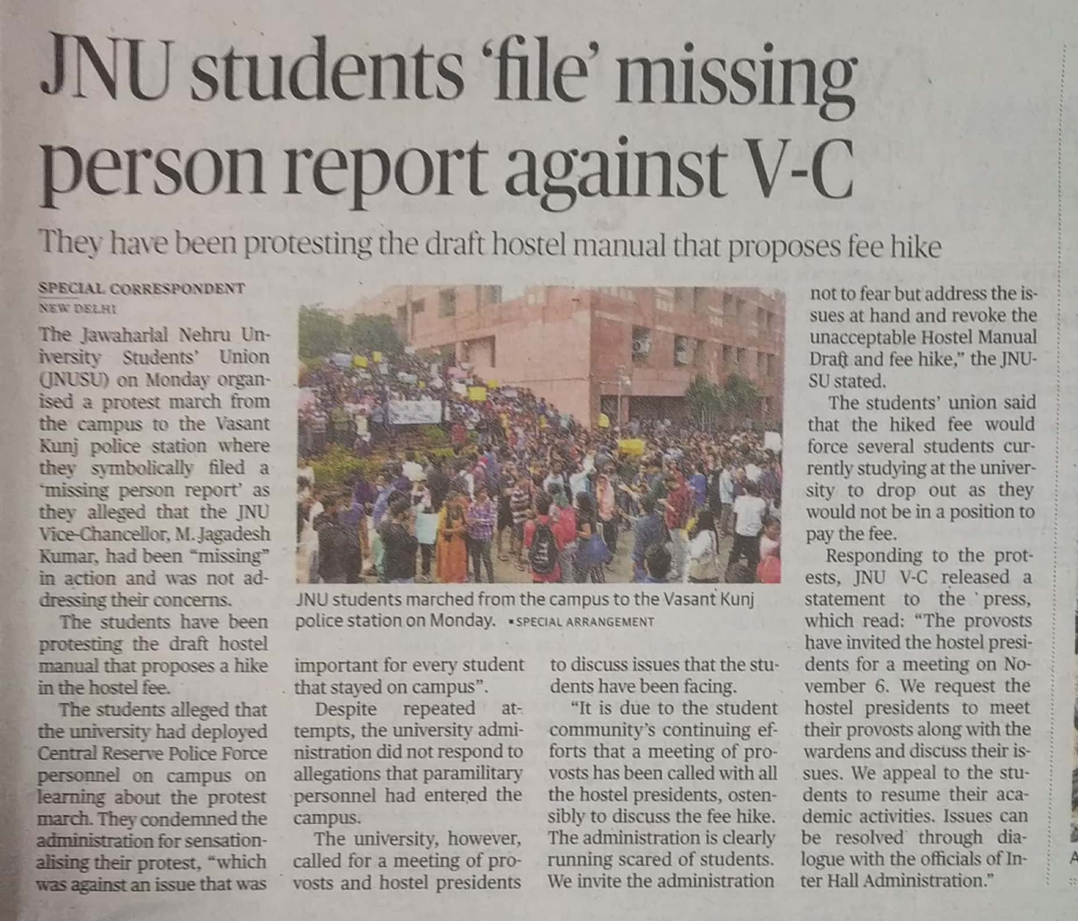

The Hindu 05 Nov. 2019