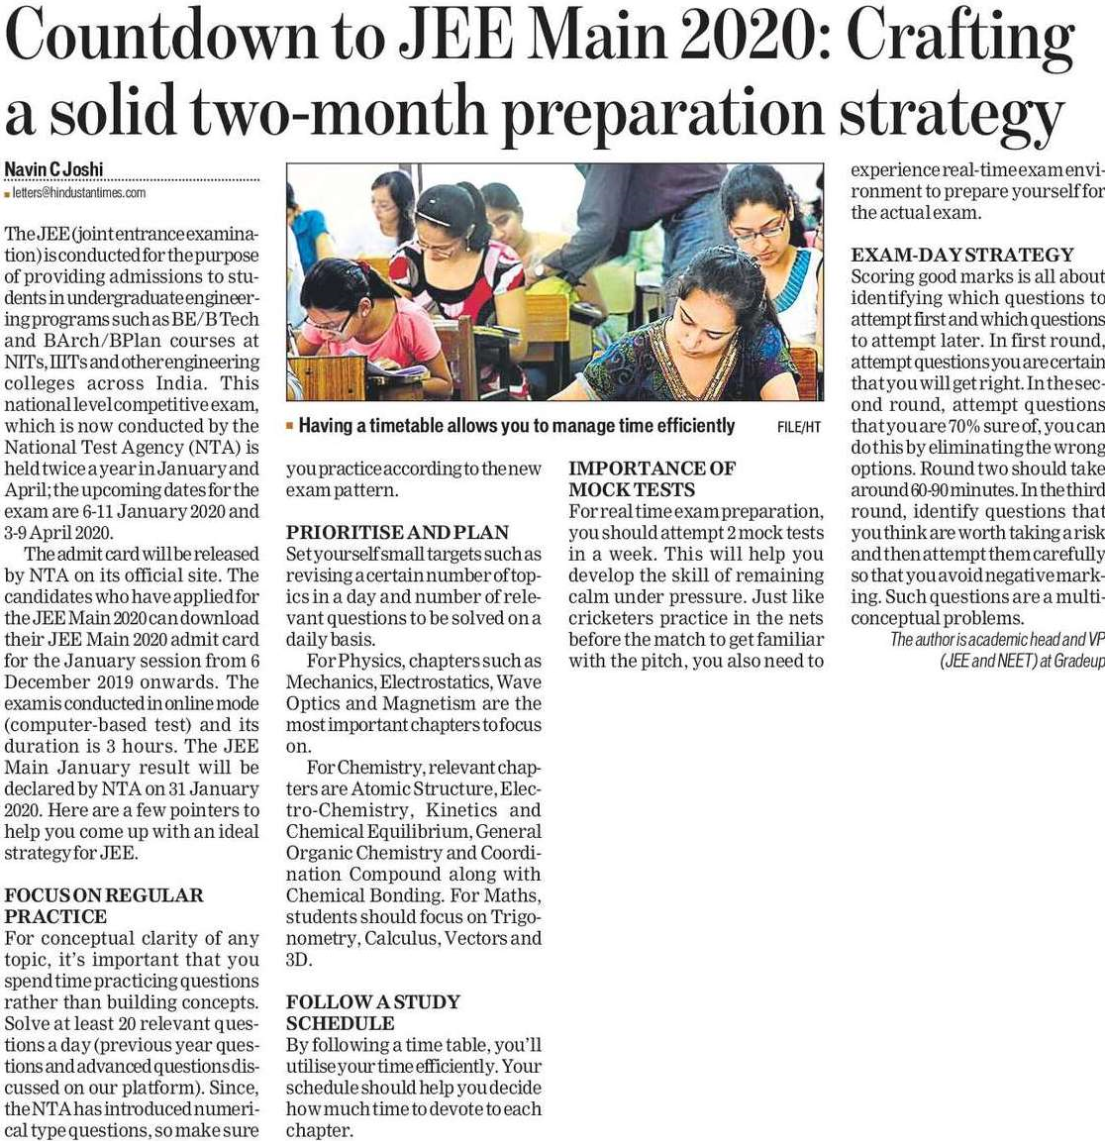

Hindustan Times 13 Nov. 2019