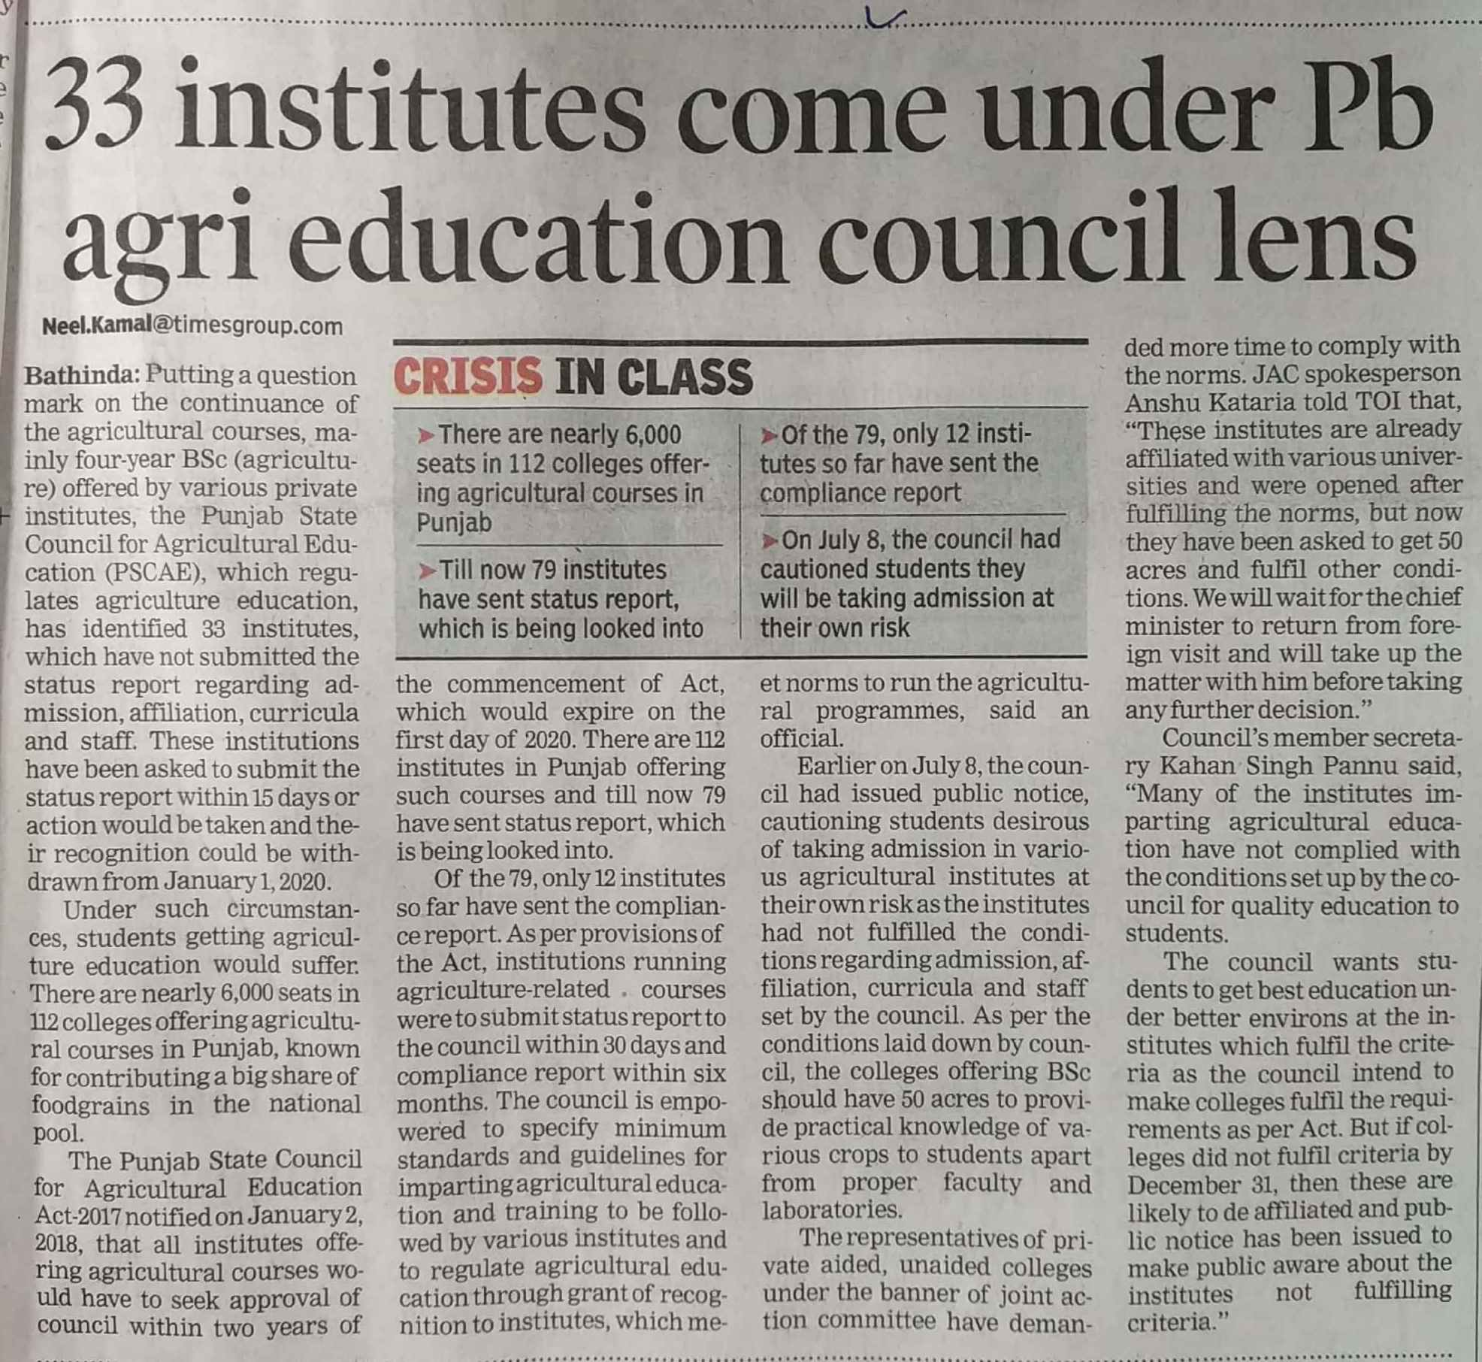

Times of India 22 Nov. 2019