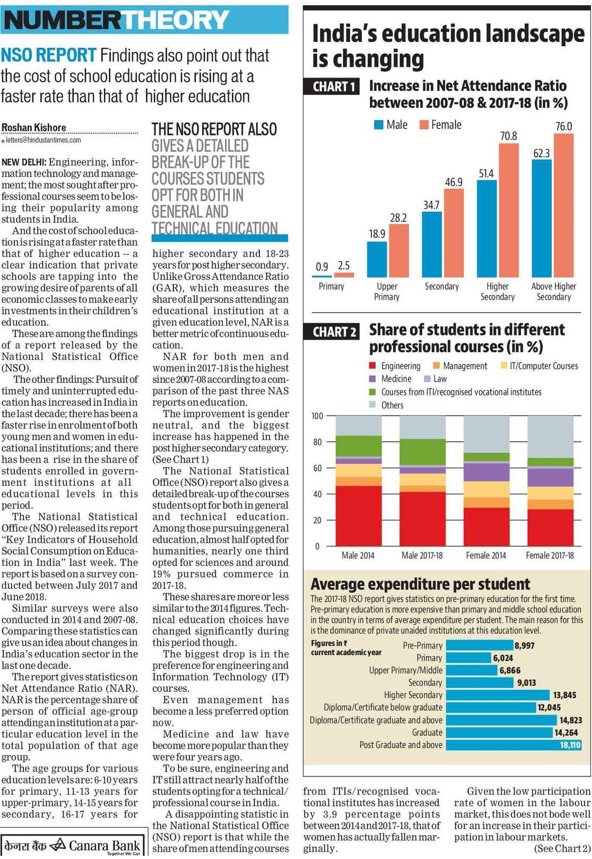

Hindustan Times 26 Nov. 2019 Done