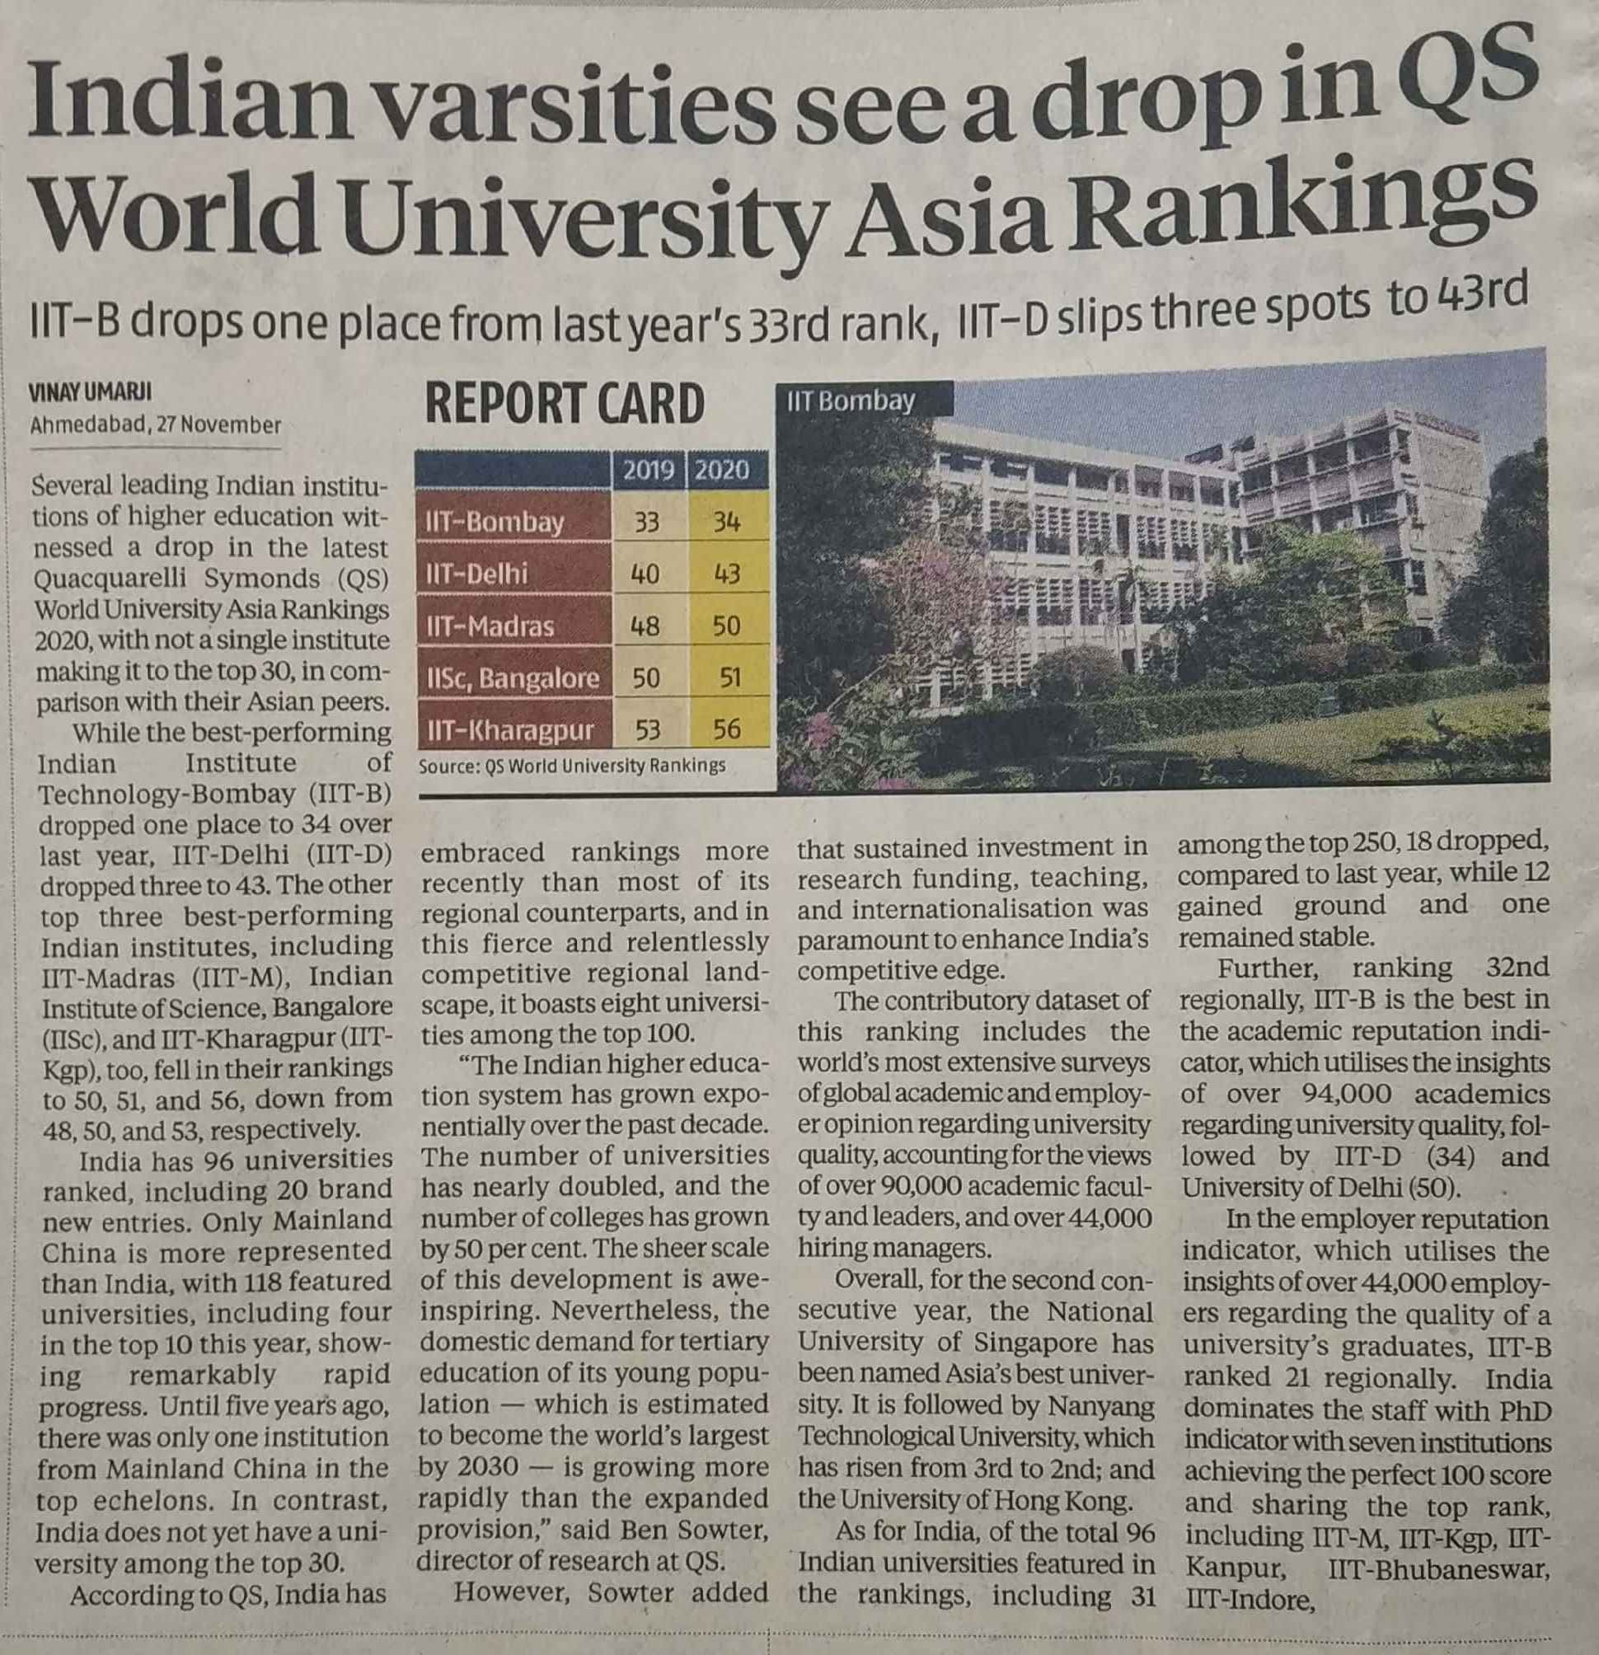

Business Standard 28 Nov. 2019

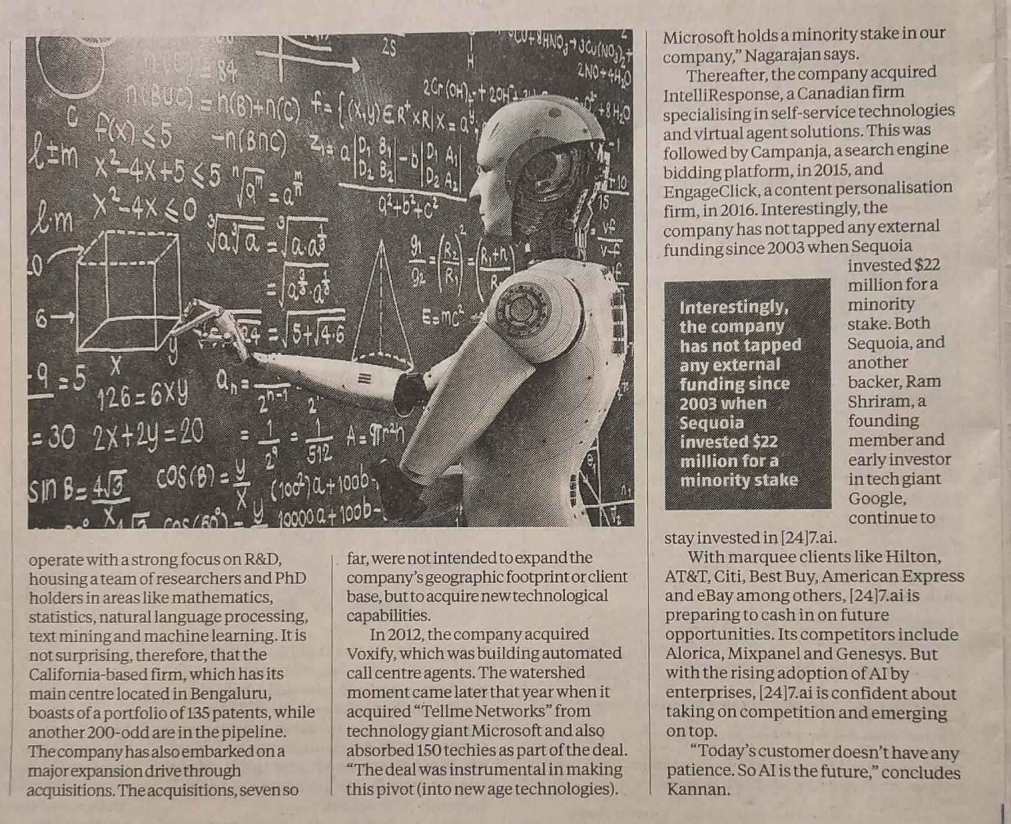

Business Standard 28 Nov. 2019