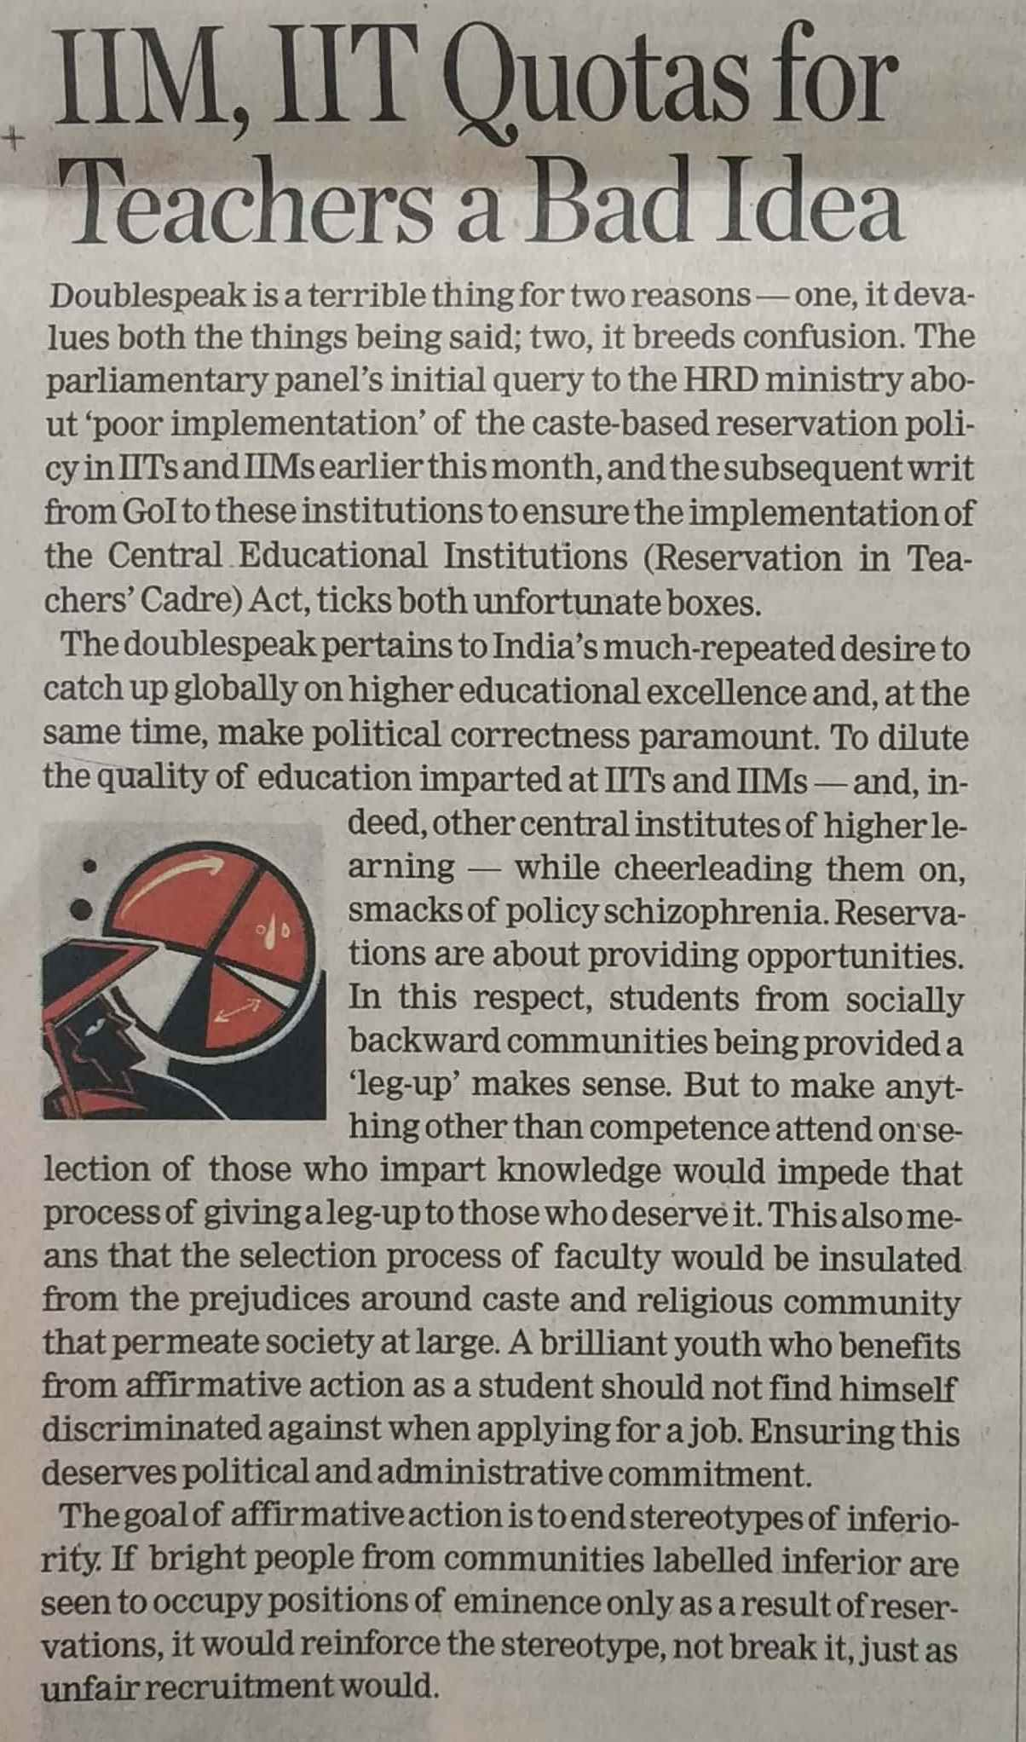

Economics Times 28 Nov. 2019