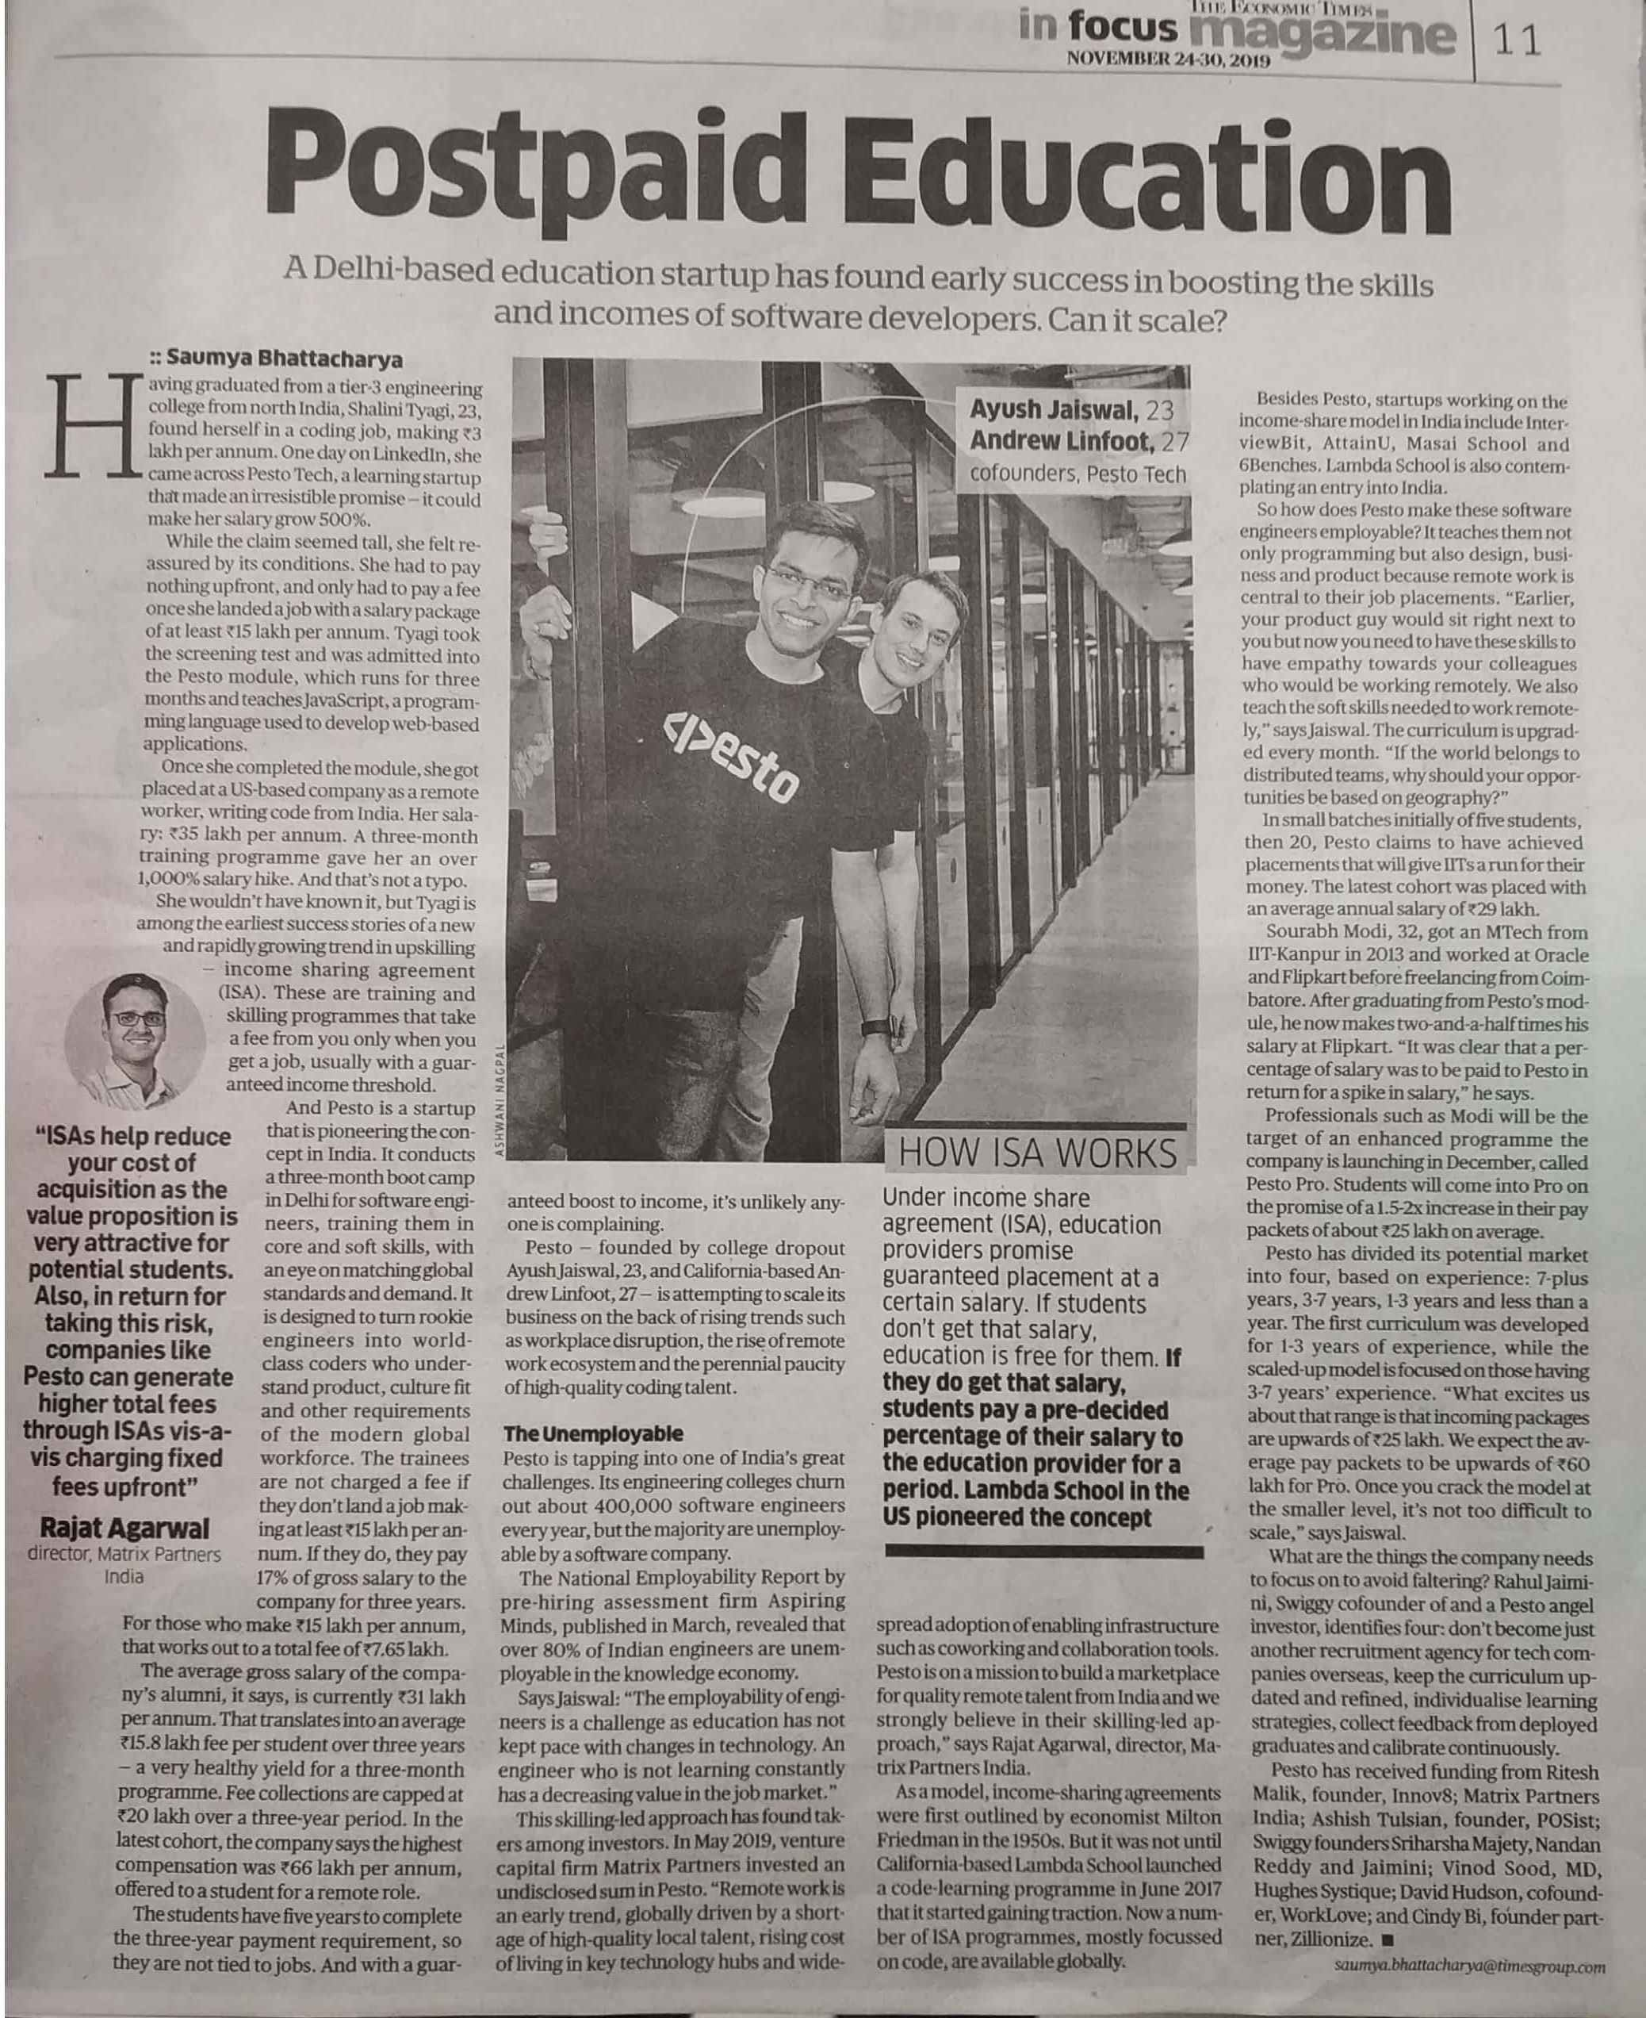

Economics Times 24 Nov. 2019

Economics Times 28 Nov. 2019