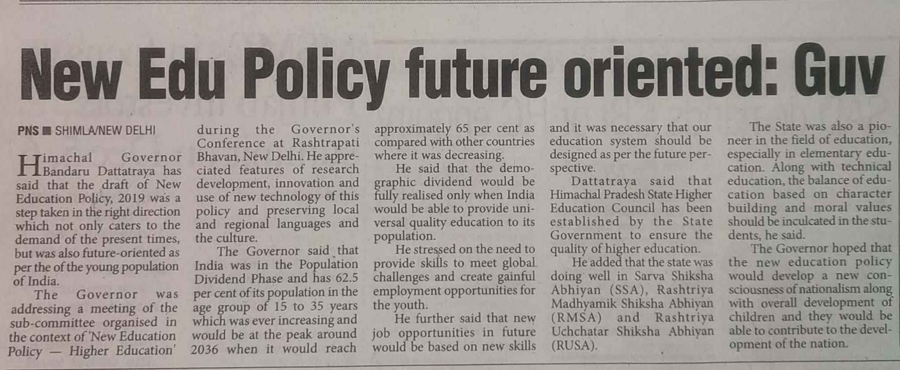

The Pioneer 25 Nov. 2019