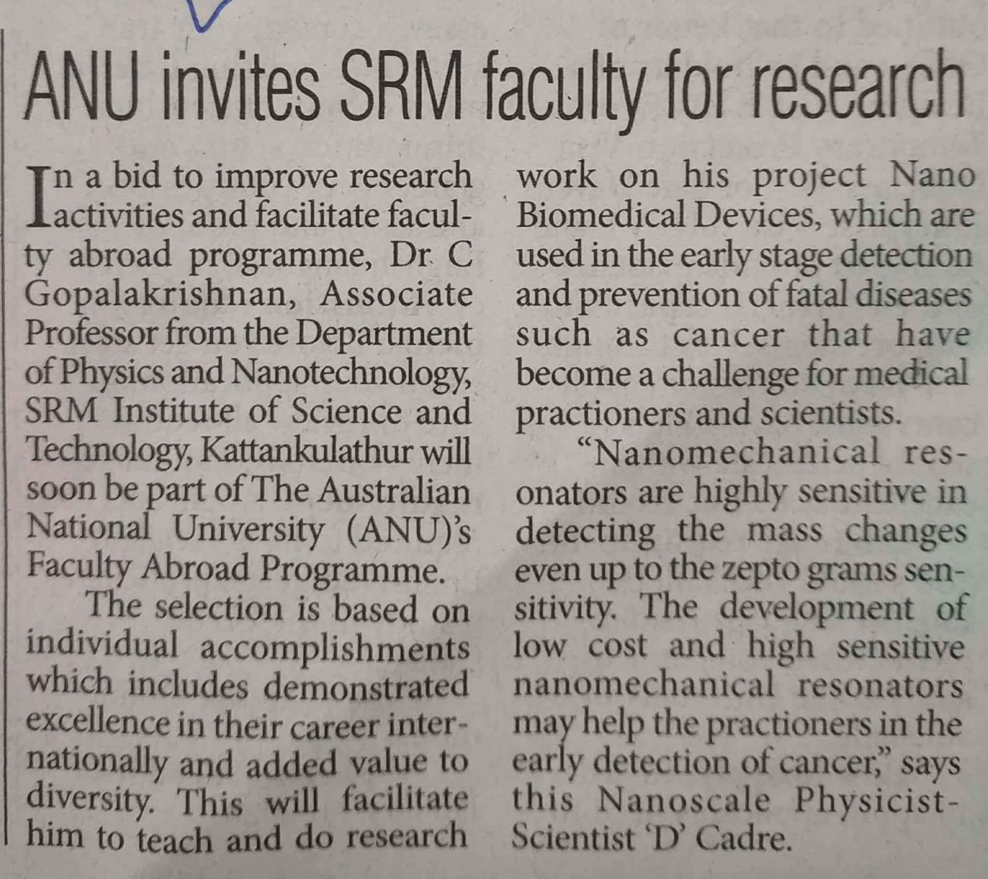

The Pioneer 28 Nov. 2019