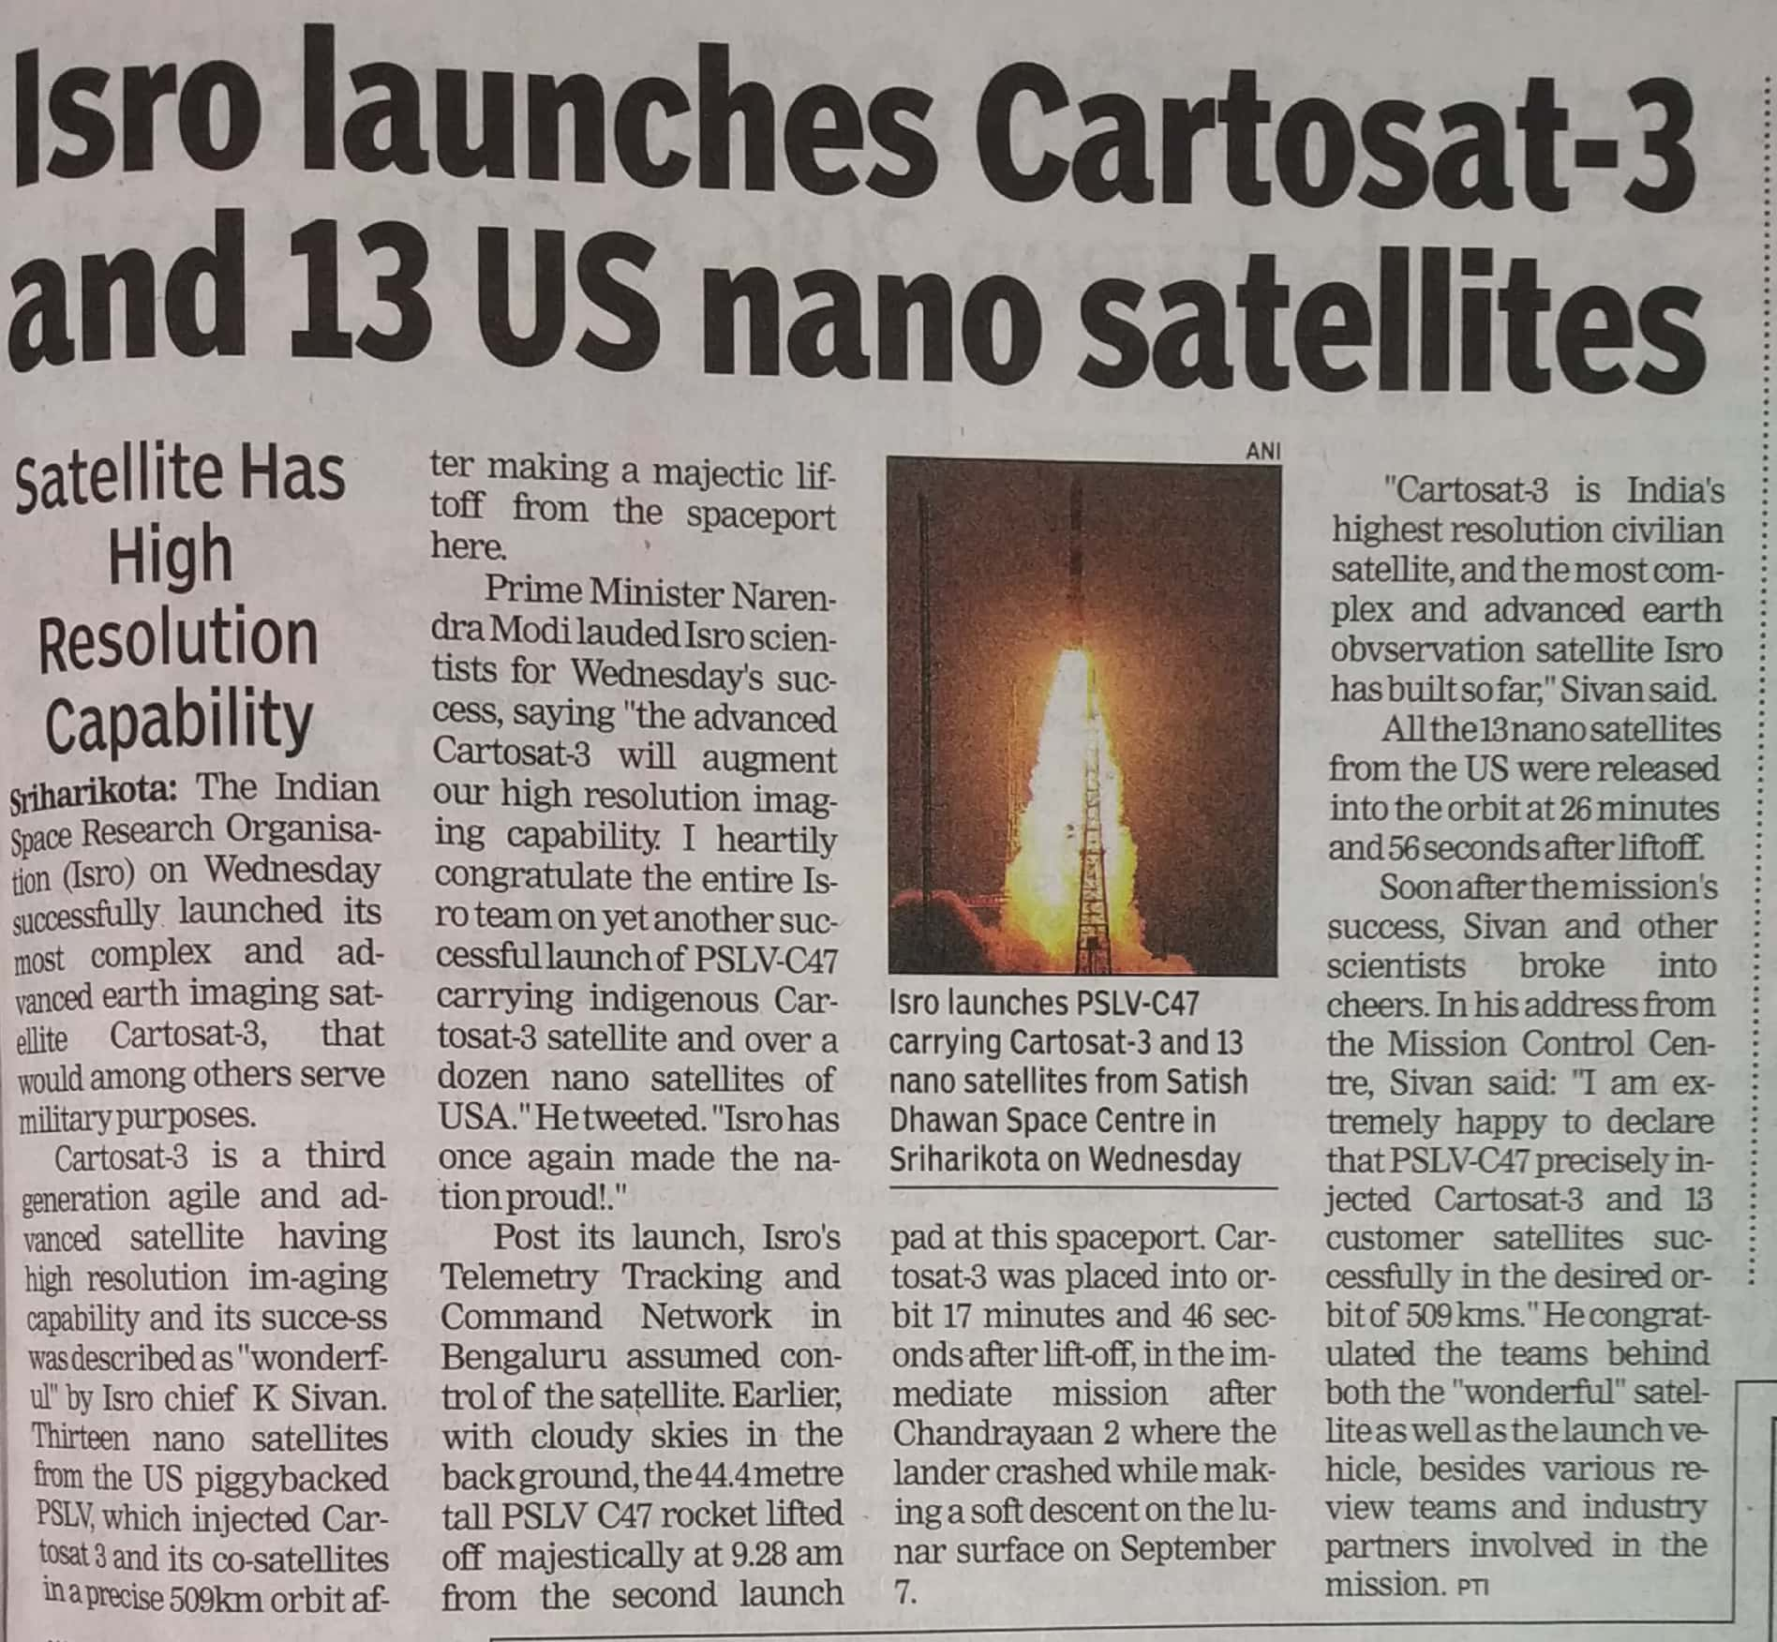

Times of India 28 Nov. 2019

A