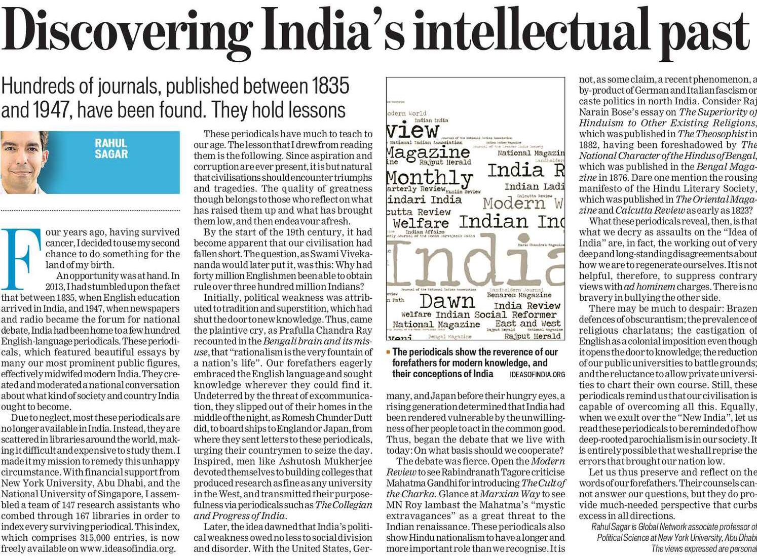

Hindustan Times 02 Dec. 2019