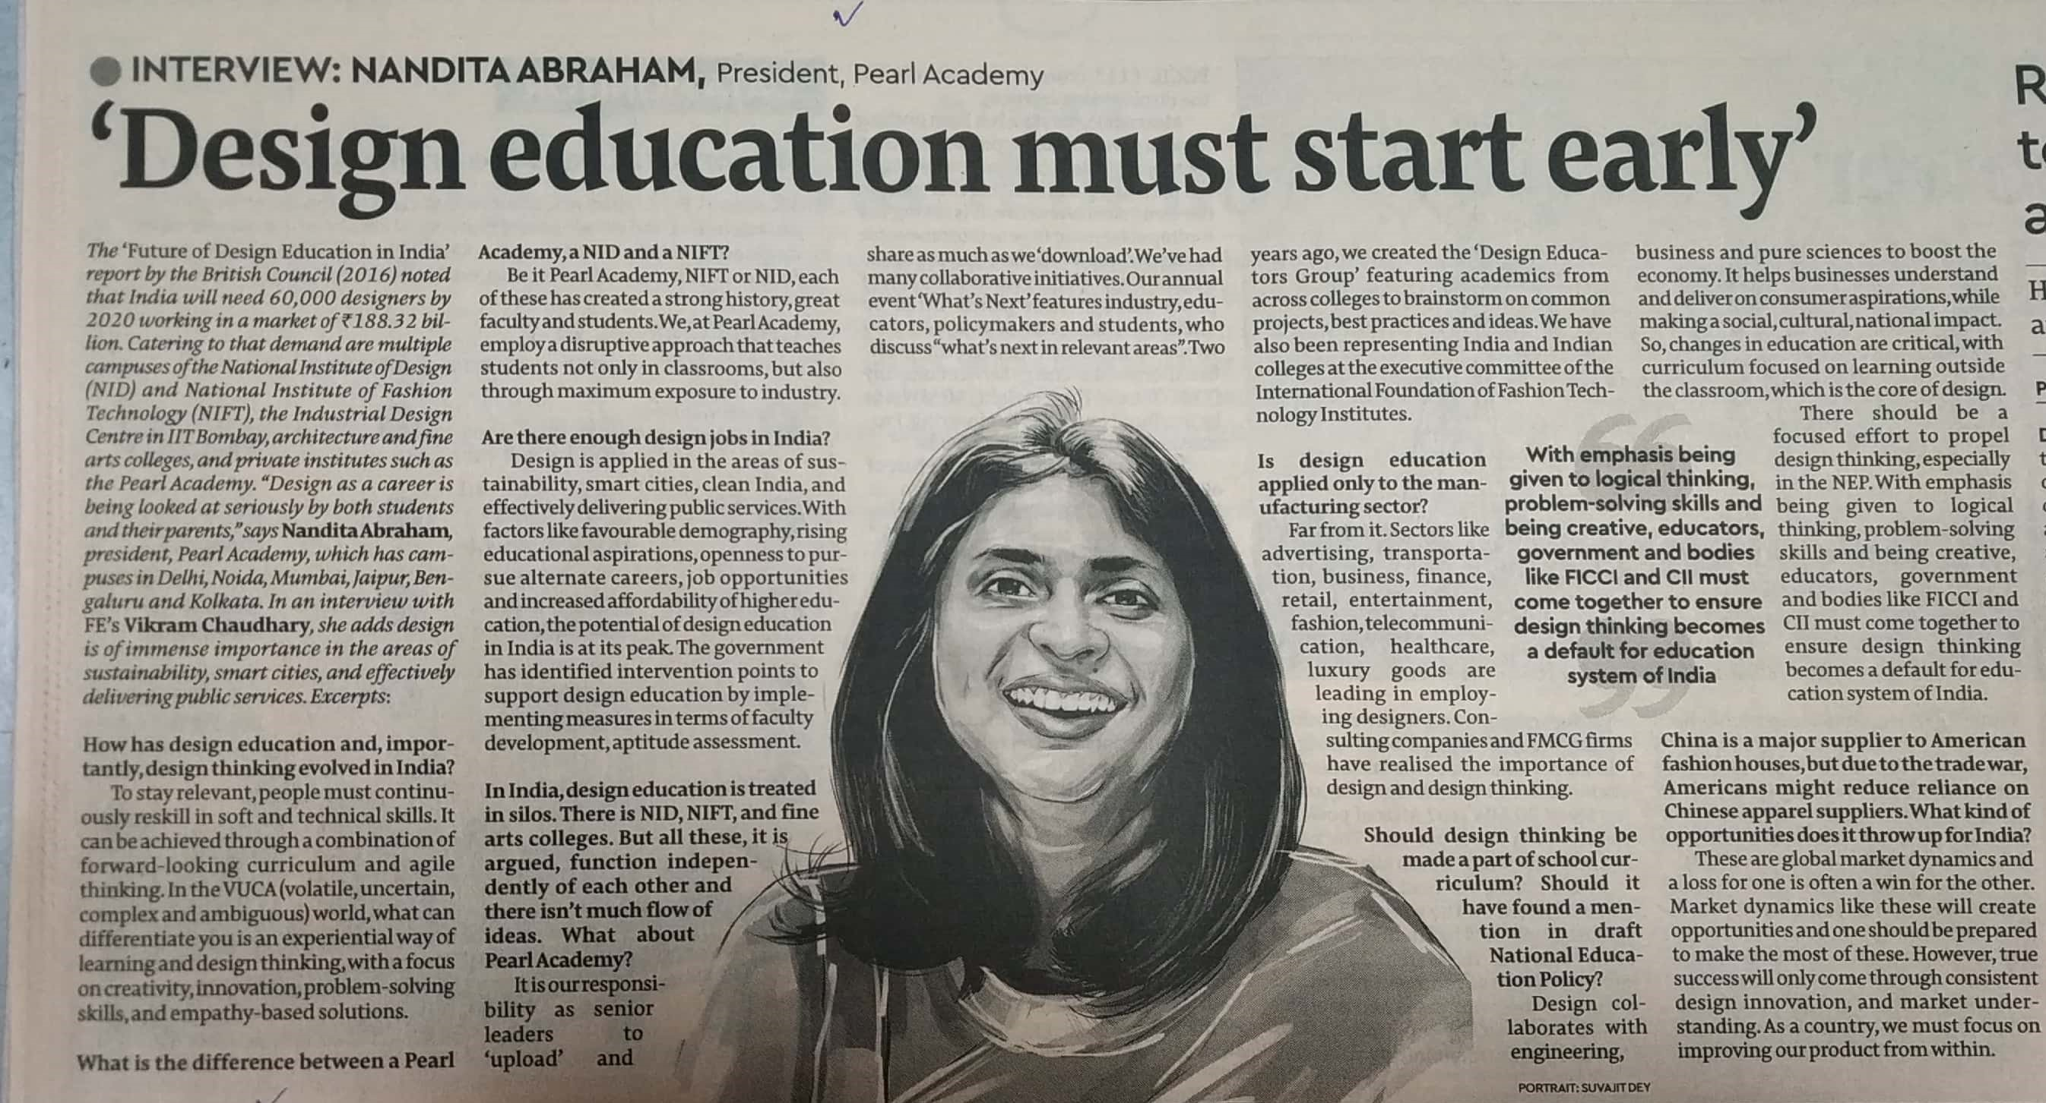

Financial Express 02 Dec. 2019