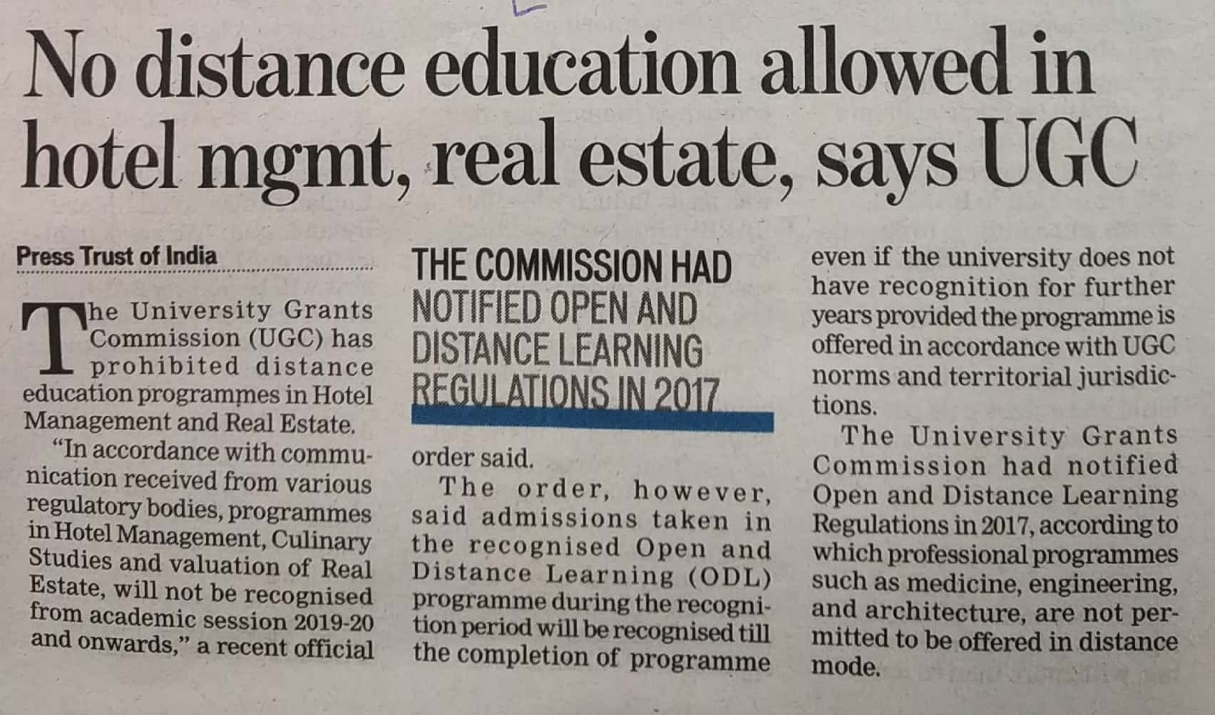

Hindustan Times 05 Dec. 2019