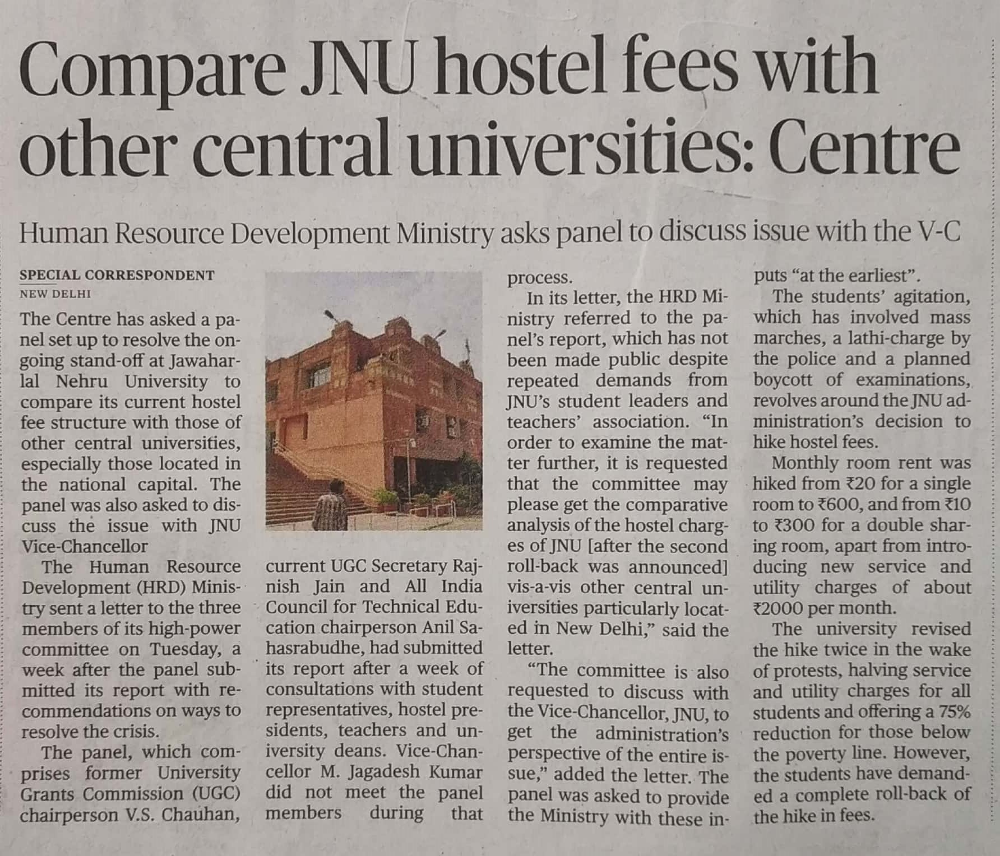

The Hindu 05 Dec. 2019