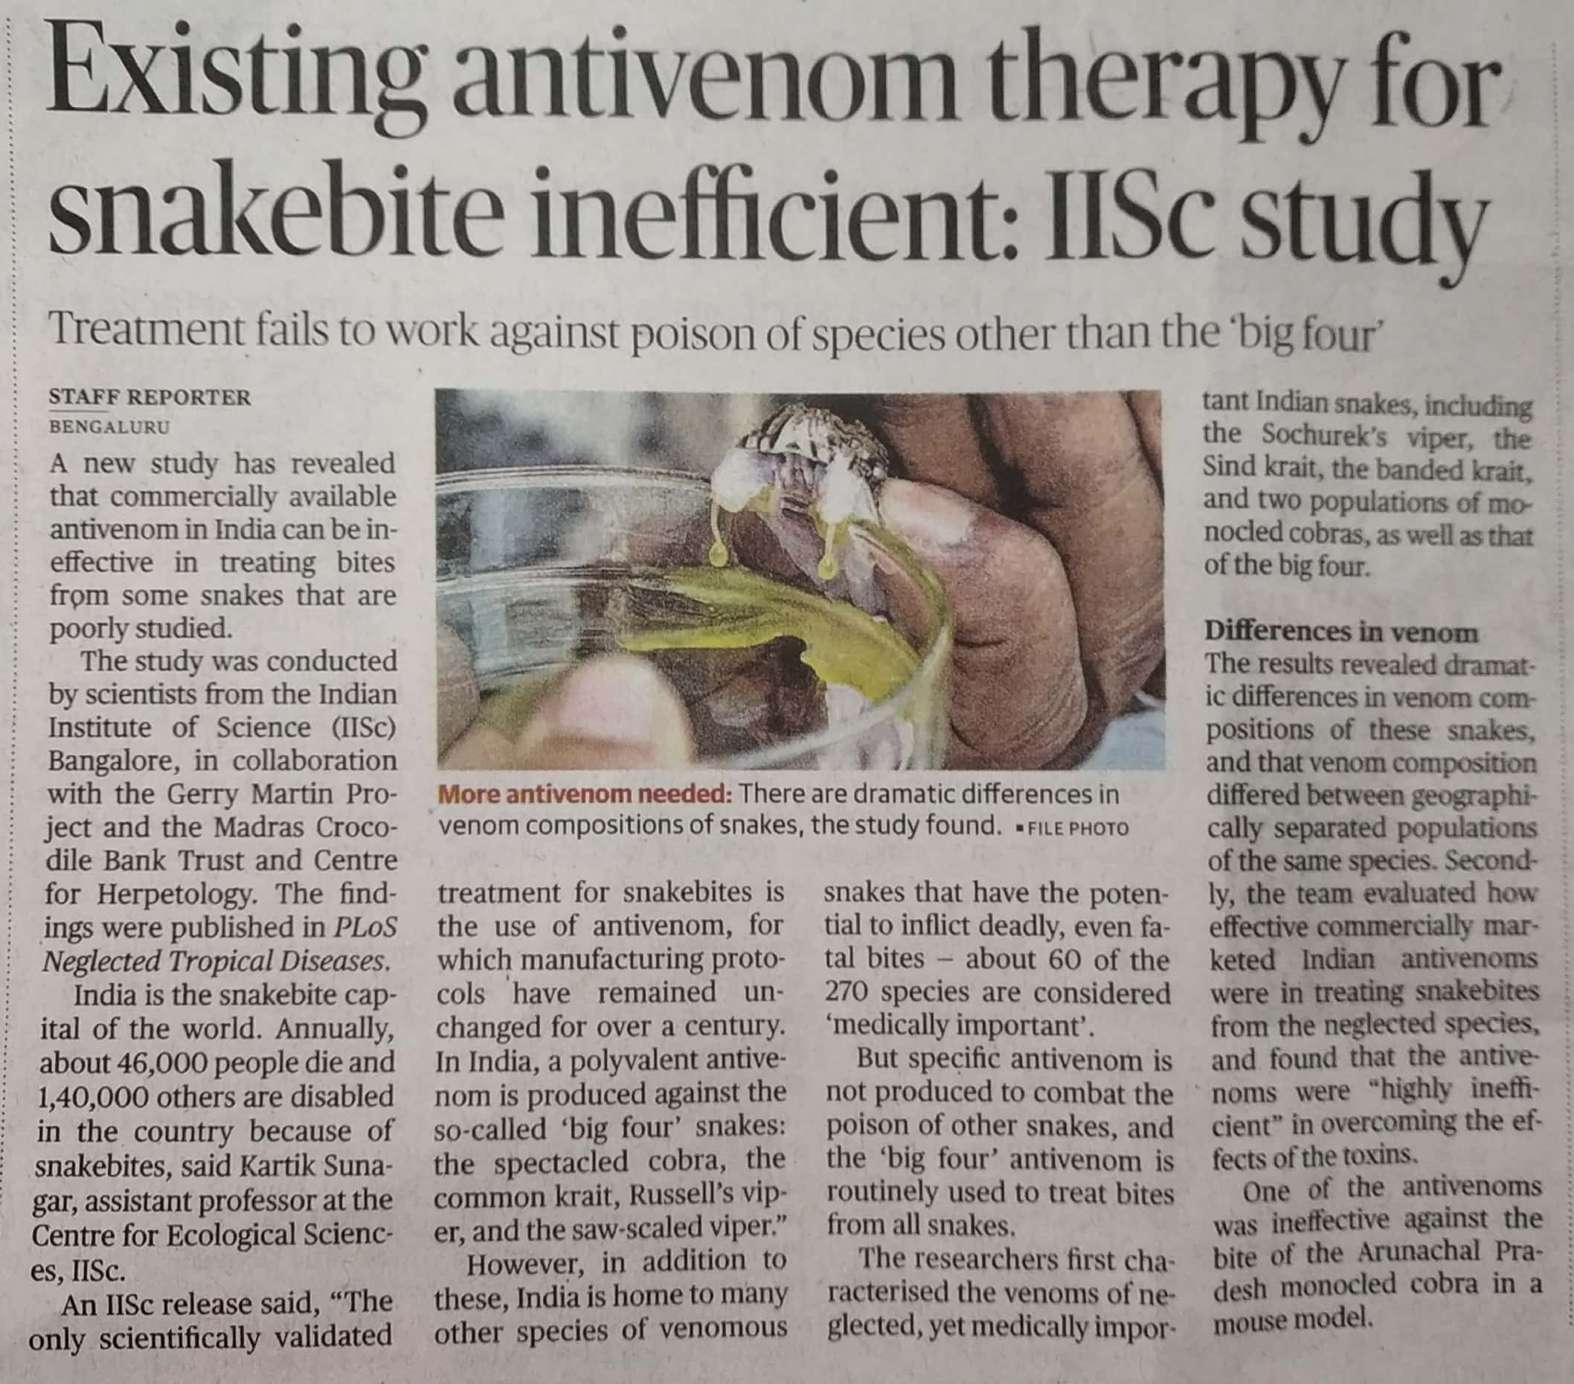

The Hindu 07 Dec. 2019