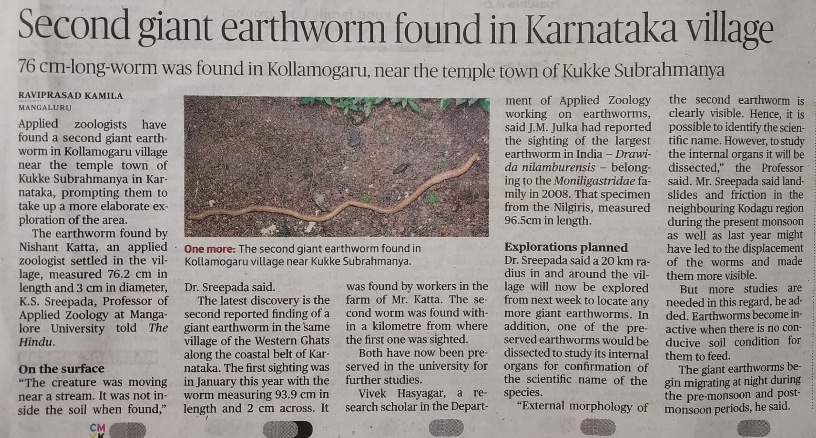

The Hindu 08 Dec. 2019