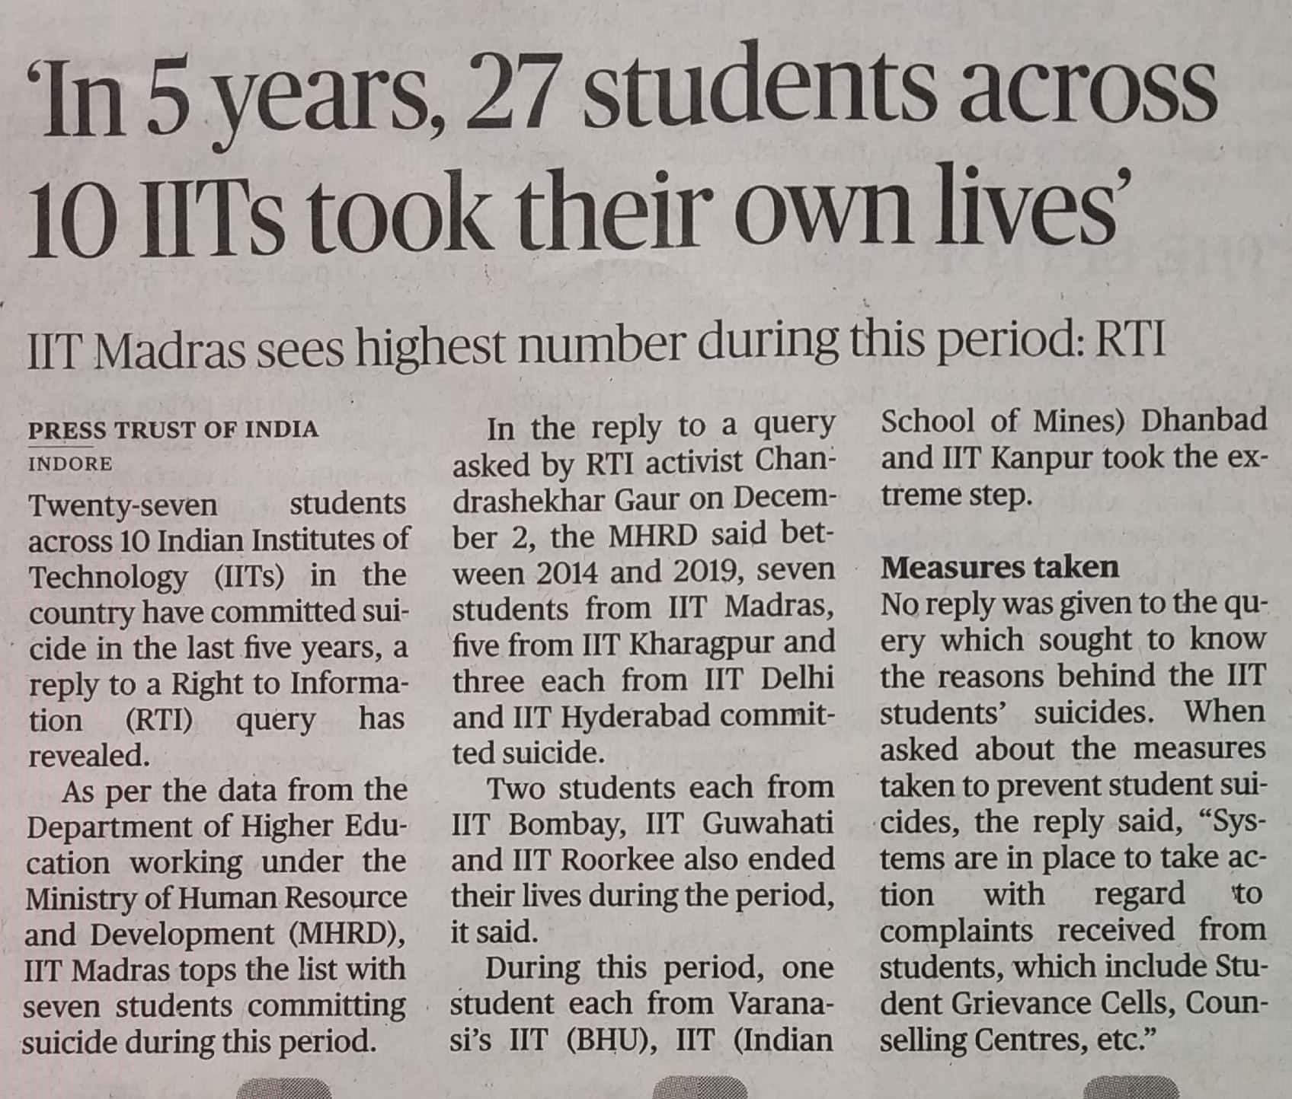

The Hindu 09 Dec. 2019