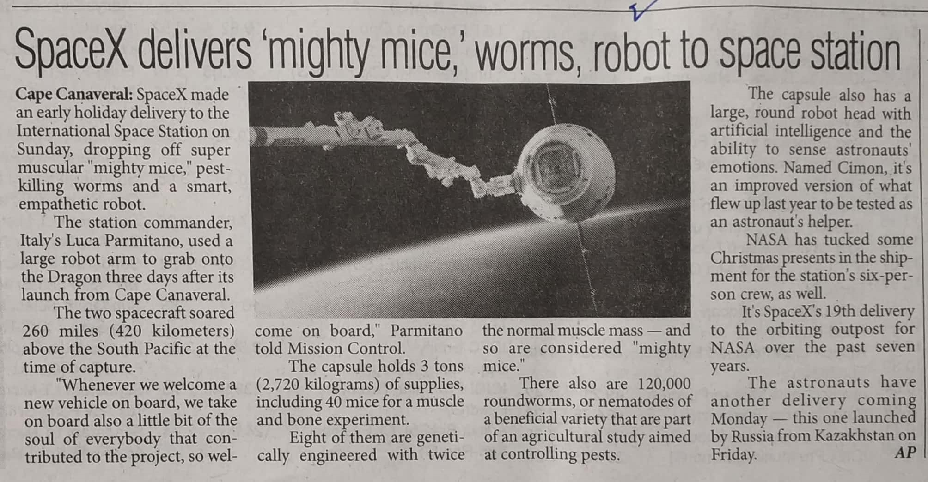

The Pioneer 09 Dec. 2019