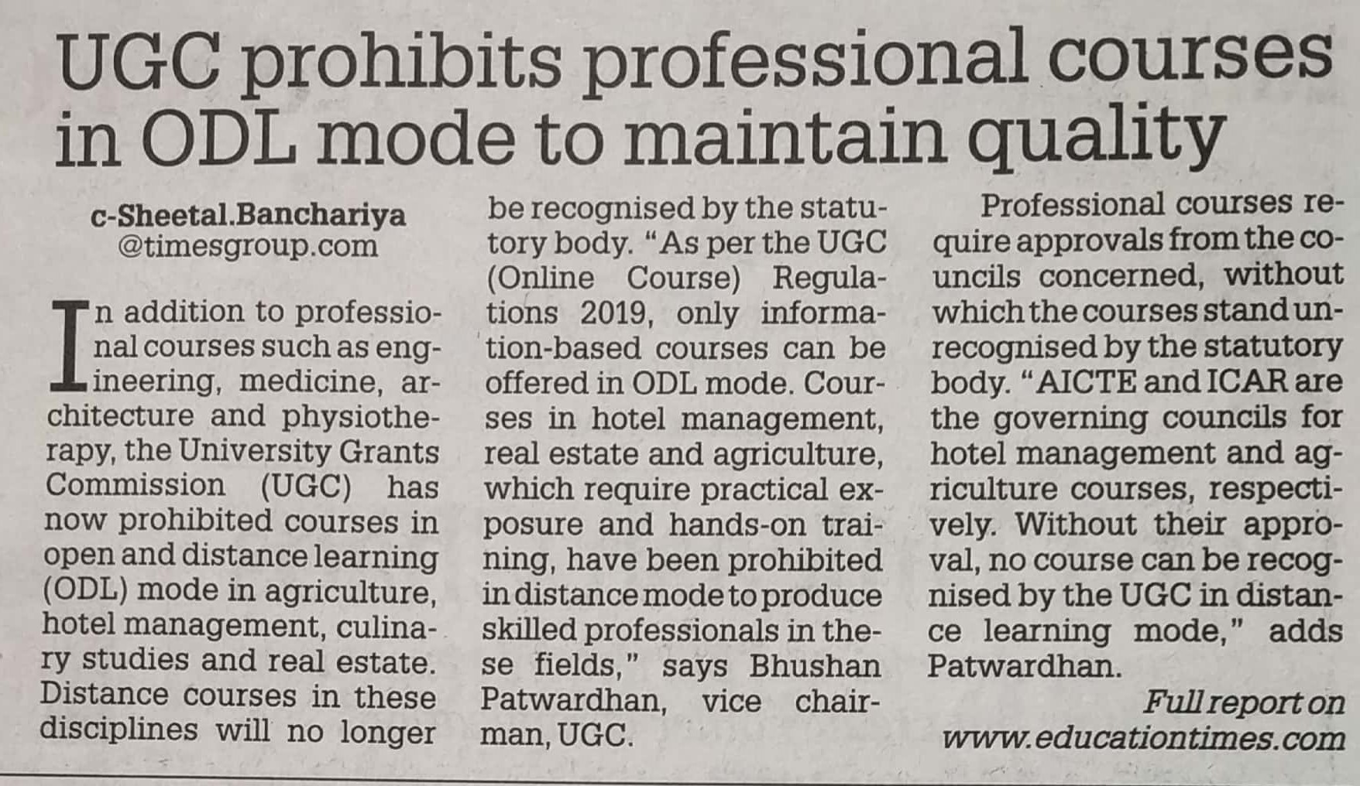

Times of India 09 Dec. 2019