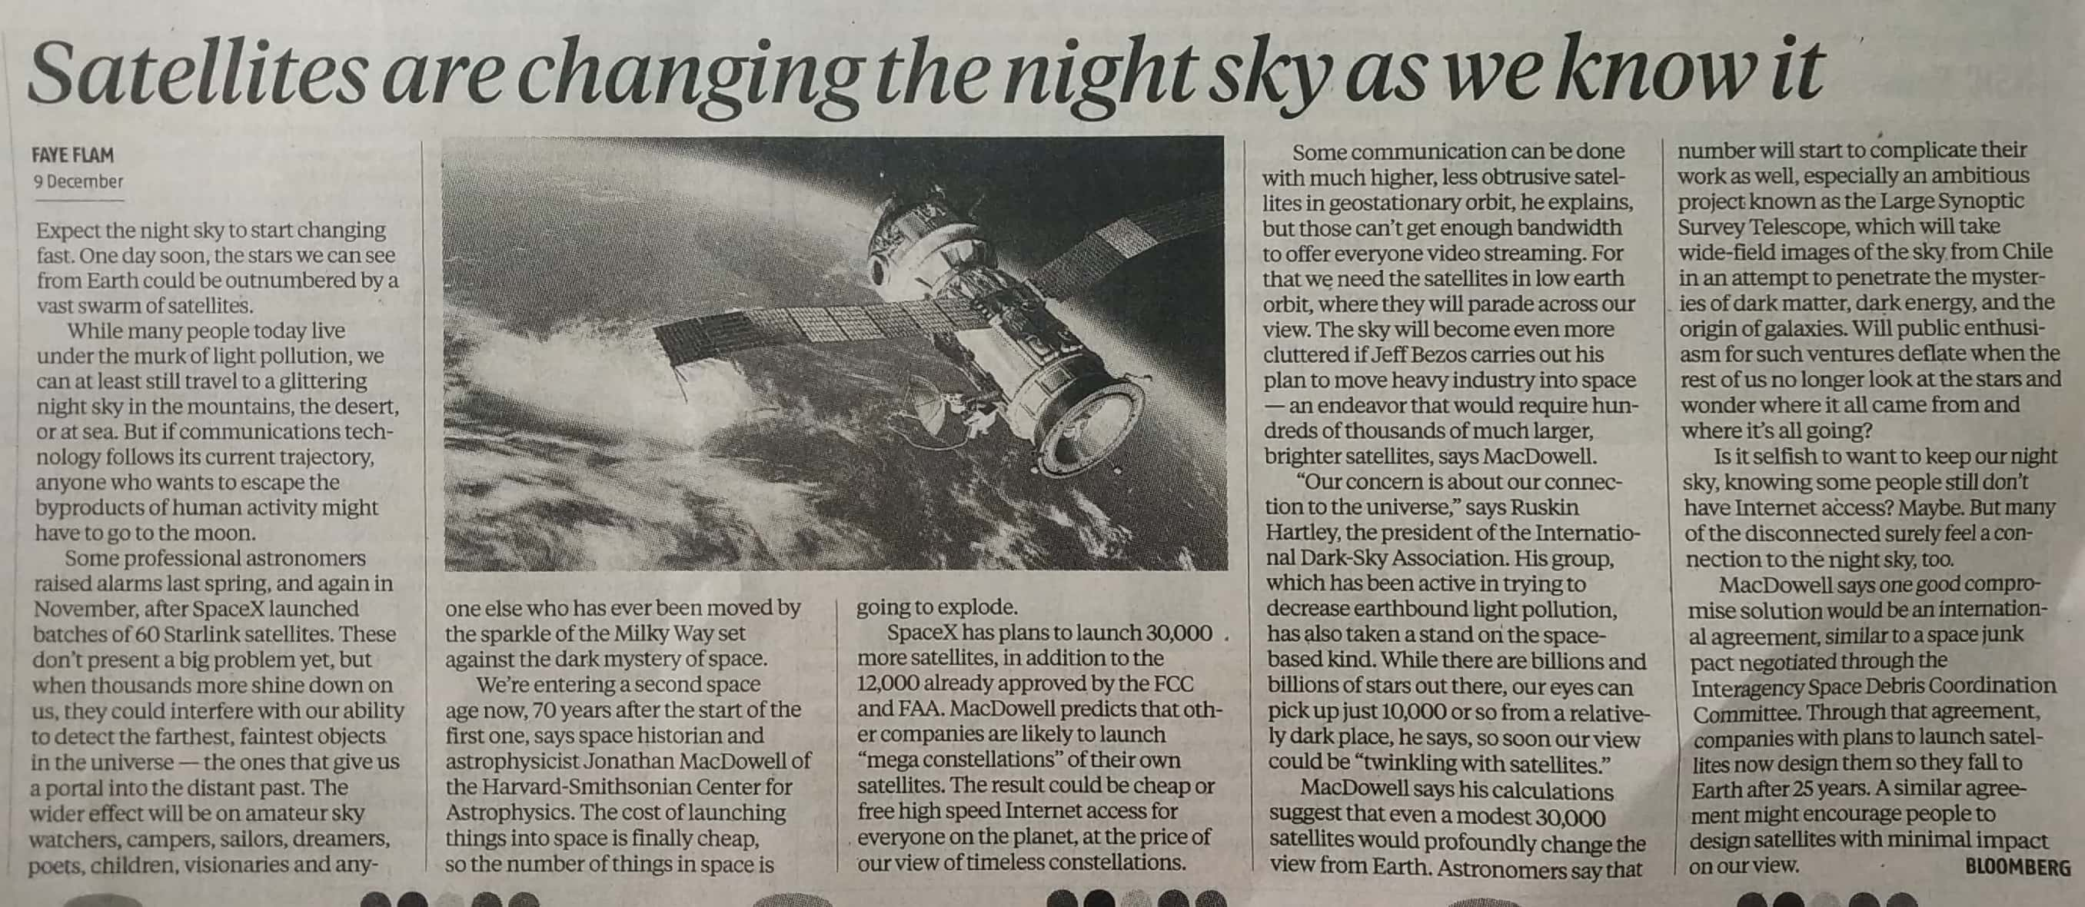

Business Standard 10 Dec. 2019