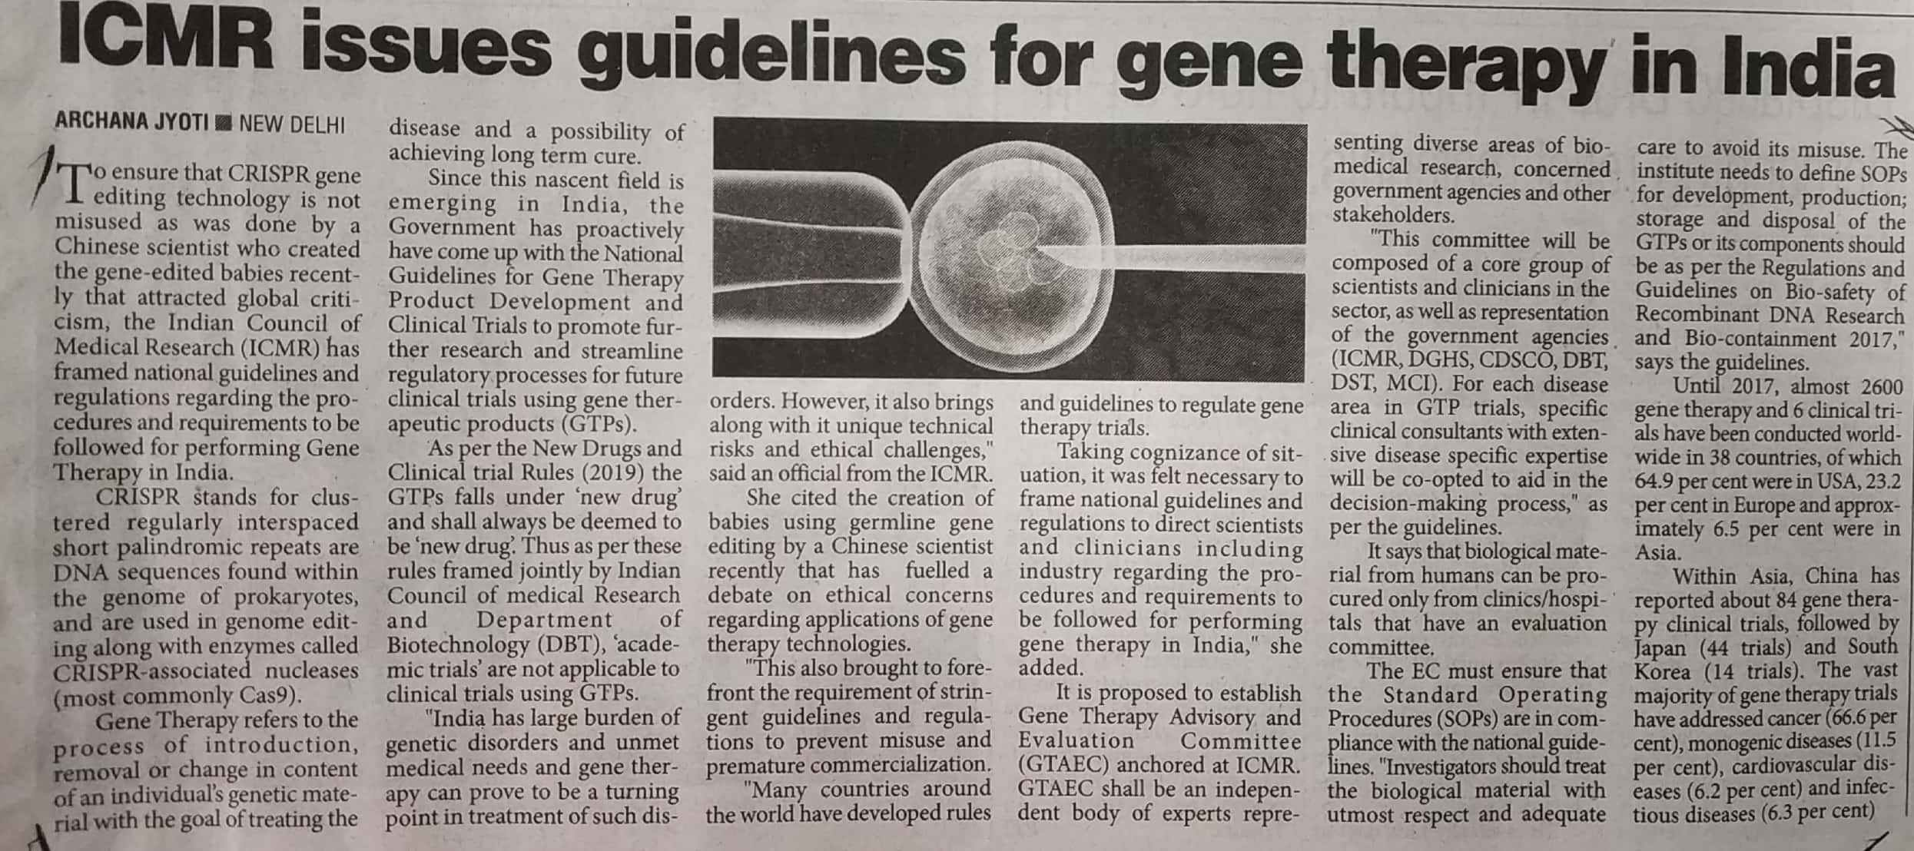

The Pioneer 10 Dec. 2019